HEALTH CARE MANAGEMENT SYSTEM

BUAN 6320 – Data base foundations for business analytics

**Group- 6**

Don Thoppil Jain Sushma Bukkapuram Tara Canugovi

Mounika Kolle

Venkata Lakshmi Ishwarya Tatavarthi

Table of Contents:

Introduction 2

Requirement definition details 2

* Entity and Attribute description 2
* Relationship and Cardinality description 4
* Assumptions and Special Considerations 5
* Normalization 6
* Entity Relationship Diagram (ERD) 8

3. Technical Report ------------------------------------------------------------------------------------------------10

* Data Definition Language --------------------------------------------------------------------10
* Data Manipulation Language ----------------------------------------------------------------18

a) DML Code

b) Query Code and Output

4. Conclusion---------------------------------------------------------------------------------------------------------40

# Introduction:

This database design document describes the requirements and defines the Entity Relationship Diagram (ERD) for a Health Care Management System database. The system enables patients to book an

appointment with the doctor and have a track of lab test and medical records.

# Requirement Definition Details:

Entity and Attribute description

Here's a description of each entity and its attributes from the healthcare management system ER diagram:

# Patients:

Description: This entity represents the individuals receiving medical care within the healthcare system. Attributes:

* + PatientID: Unique identifier for each patient.
  + Name: Full name of the patient.
  + DateOfBirth: Birthdate of the patient.
  + Gender: Gender of the patient.
  + ContactInfo: Contact details, such as phone number or email.
  + Address: Home address of the patient.
  + MedicalHistory: Summary of the patient's past medical history.

# Doctor:

Description: Represents the healthcare providers who diagnose and treat patients. Attributes:

* + DoctorID: Unique identifier for each doctor.
  + Name: Full name of the doctor.
  + Department: Department in which the doctor works.
  + Specialty: Medical specialty of the doctor.
  + Experience: Years of experience the doctor has.
  + ContactInfo: Contact information, such as phone number or email.

# Appointment:

Description: Tracks the scheduled meetings between patients and doctors. Attributes:

* + AppointmentID: Unique identifier for each appointment.
  + PatientID (FK): Foreign key linking to the patient attending the appointment.
  + DoctorID (FK): Foreign key linking to the doctor assigned to the appointment.
  + Date: Date and time of the appointment.
  + AppointmentReason: Reason for the appointment.
  + Status: Status of the appointment (e.g., scheduled, completed, canceled).

# Billing:

Description: Records of payment information related to patient appointments. Attributes:

* + BillID: Unique identifier for each billing record.
  + PatientID (FK): Foreign key linking to the patient associated with the bill.
  + AppointmentID (FK): Foreign key linking to the appointment that generated the bill.
  + TotalAmount: Total cost for the appointment.
  + Date: Date the bill was generated.
  + PaymentStatus: Status of the payment (e.g., paid, pending).
  + InsuranceDetails: Information on insurance coverage, if applicable.

# MedicalRecord:

Description: Documents of the medical details and treatment history of patients. Attributes:

* + RecordID: Unique identifier for each medical record.
  + PatientID (FK): Foreign key linking to the patient to whom the record belongs.
  + AppointmentID (FK): Foreign key linking to the appointment associated with the record.
  + DoctorID (FK): Foreign key linking to the doctor responsible for the record.
  + Notes: Doctor's notes regarding the patient's condition.
  + Treatment: Description of treatments provided.

# Lab_Tests:

Description: Represents various lab tests conducted as part of a patient’s medical care. Attributes:

* + TestID: Unique identifier for each lab test.
  + RecordID (FK): Foreign key linking to the medical record associated with the test.
  + TestName: Name of the lab test (e.g., blood test, MRI).
  + Attribute4: Additional attribute, potentially used for specific test characteristics.
  + TestDate: Date the test was performed.
  + Result: Result or outcome of the lab test.
  + DoctorNotes: Notes from the doctor regarding the test results.
  + Each entity in this system has attributes to identify the key information required for managing patient care, medical records, and billing in a healthcare setting.

Relationship and Cardinality description:

# Patients - Appointments

* + Relationship: A patient can schedule one or more appointments.
  + Cardinality: 1:M from Patients to Appointments.
  + Description: Each patient can have multiple appointments, but each appointment is linked to one specific patient.

# Doctors - Appointments

* + Relationship: A doctor can have one or more appointments with different patients.
  + Cardinality: 1:M from Doctors to Appointments.
  + Description: Each doctor can be assigned multiple appointments, but each appointment is assigned to only one doctor.

# Patients – MedicalRecords

* + Relationship: Each patient can have multiple medical records.
  + Cardinality: 1:M from Patients to MedicalRecords.
  + Description: A patient may have multiple medical records over time, each corresponding to an appointment or treatment.

# Appointments – MedicalRecords

* + Relationship: Each appointment generates a medical record.
  + Cardinality: 1:1 from Appointments to MedicalRecords.
  + Description: Each appointment corresponds to one unique medical record, capturing the treatment and diagnosis.

# Doctors - MedicalRecords

* + Relationship: A doctor contributes to multiple medical records for different patients.
  + Cardinality: 1:M from Doctors to MedicalRecords.
  + Description: Each doctor may be associated with multiple medical records if they treated multiple patients, but each medical record is linked to one specific doctor.

# MedicalRecords - LabTests

* + Relationship: Each medical record can have one or more lab tests associated with it.
  + Cardinality: 1:M from MedicalRecords to LabTests.
  + Description: Each medical record may involve multiple lab tests conducted as part of the patient's treatment or diagnosis.

# Patients - Billing

* + Relationship: Each patient can have multiple bills.
  + Cardinality: 1:M from Patients to Billing.
  + Description: A patient can have multiple bills generated for different appointments or treatments, but each bill corresponds to one specific patient.

# Appointments – Billing

* + Relationship: Each appointment generates a bill.
  + Cardinality: 1:1 from Appointments to Billing.
  + Description: Each appointment has a single bill associated with it, capturing the cost of services provided in that session.

Assumptions and Special Considerations:

1. Patient Registration: It is assumed that each patient must be registered in the system before scheduling appointments.
2. Unique Identifiers: Each patient, doctor, appointment, and medical record has a unique identifier to ensure accurate data tracking.
3. Standardized Contact Information: Patient and doctor contact information (e.g., phone numbers) is stored in a standardized format.
4. Insurance Information: It is assumed that billing records may include insurance details, with payment status updated as claims are processed.
5. Role-Based Access Control: Access to sensitive patient data is limited based on user roles (e.g., doctors, billing staff) to ensure data privacy and compliance.

These assumptions and considerations ensure data accuracy, privacy, and compliance in the healthcare management system.

Normalization:

To demonstrate the normalization process of the hospital database schema up to the Third Normal Form (3NF), let's go through each step, identifying and resolving dependencies and documenting how we address any transitive dependencies.

# Step 1: First Normal Form (1NF)

Definition: In 1NF, each table should contain only atomic values (no repeating groups or arrays).

# Current Schema:

* Patients: PatientID, Name, DateOfBirth, Gender, ContactInfo, Address, MedicalHistory
* Doctors: DoctorID, Name, Specialty, ContactInfo, Department, Experience
* Appointments: AppointmentID, PatientID (FK), DoctorID (FK), Date, Time, AppointmentReason, Status
* MedicalRecords: RecordID, PatientID (FK), AppointmentID (FK), DoctorID (FK), Diagnosis, Treatment, Notes
* LabTests: TestID, RecordID (FK), TestName, TestDate, Result, DoctorNotes
* Billing: BillID, PatientID (FK), AppointmentID (FK), TotalAmount, PaymentStatus, Date, InsuranceDetails

**Analysis**: Each attribute in these tables is already atomic (i.e., single-valued), so the schema satisfies 1NF.

# Step 2: Second Normal Form (2NF)

Definition: In 2NF, the schema must be in 1NF, and all non-key attributes must be fully dependent on the primary key (no partial dependencies).

# Current Schema Analysis:

* Each table has a single primary key: PatientID for Patients, DoctorID for Doctors, AppointmentID for Appointments, RecordID for MedicalRecords, TestID for LabTests, and BillID for Billing.
* In each table, all non-key attributes depend fully on their respective primary keys, so there are no partial dependencies.

**Conclusion**: Each table satisfies 2NF.

# Step 3: Third Normal Form (3NF)

Definition: In 3NF, the schema must be in 2NF, and there should be no transitive dependencies (i.e., non- key attributes should not depend on other non-key attributes).

**Identifying and Resolving Transitive Dependencies**: To demonstrate resolving a transitive dependency, let’s focus on an example within the **Billing** table.

Billing Table Example

Attributes: BillID, PatientID (FK), AppointmentID (FK), TotalAmount, PaymentStatus, Date, InsuranceDetails

**Identified Transitive Dependency**: Suppose that InsuranceDetails depends on PatientID rather than

BillID, indicating that InsuranceDetails might be better associated with the patient rather than with each bill.

# Solution:

1. Remove InsuranceDetails from the Billing table.
2. Create a new table, **PatientInsurance**, which associates insurance details directly with each patient.

# Revised Billing and New PatientInsurance Tables:

* + **Billing**: BillID, PatientID (FK), AppointmentID (FK), TotalAmount, PaymentStatus, Date
  + **PatientInsurance**: PatientID, InsuranceDetails

# Updated Schema Summary in 3NF:

* + Patients: PatientID, Name, DateOfBirth, Gender, ContactInfo, Address, MedicalHistory
  + Doctors: DoctorID, Name, Specialty, ContactInfo, Department, Experience
  + Appointments: AppointmentID, PatientID (FK), DoctorID (FK), Date, Time, AppointmentReason, Status
  + MedicalRecords: RecordID, PatientID (FK), AppointmentID (FK), DoctorID (FK), Diagnosis, Treatment, Notes
  + LabTests: TestID, RecordID (FK), TestName, TestDate, Result, DoctorNotes
  + Billing: BillID, PatientID (FK), AppointmentID (FK), TotalAmount, PaymentStatus, Date
  + PatientInsurance: PatientID, InsuranceDetails

# Summary of Normalization Process

1. **1NF**: Ensured all attributes are atomic in each table.
2. **2NF**: Verified that all non-key attributes are fully dependent on the primary key in each table.
3. **3NF**: Identified a transitive dependency in the **Billing** table (InsuranceDetails depending on PatientID rather than BillID). Resolved this by moving InsuranceDetails to a new

**PatientInsurance** table, making the schema fully normalized in 3NF.

This completes the normalization process, reducing redundancy and ensuring data integrity by organizing attributes around primary keys and eliminating dependencies on non-key attributes.

Entity Relationship Diagram (ERD):

The following is the Food Delivery System database based on the requirement definition details highlighting the entity, attributes, relationships and cardinality details:

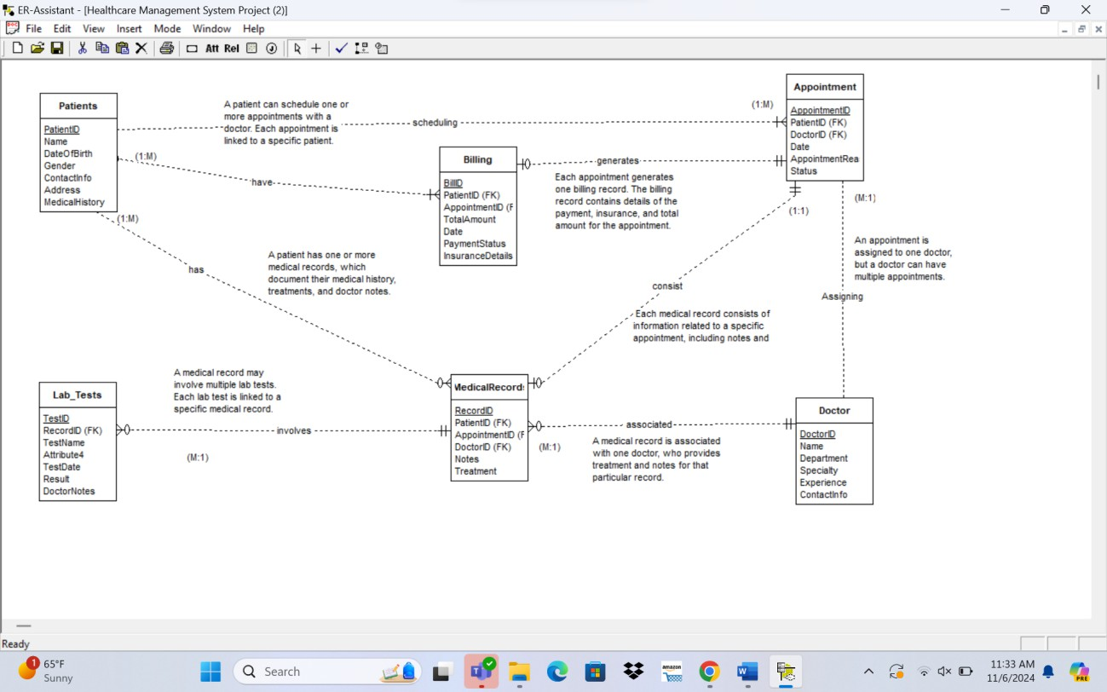

Technical Report:

I. Data Definition Language (DDL)

set search_path to healthcare_system;

-- Drop Triggers

DROP TRIGGER IF EXISTS assign_bill_id_trigger ON Billing;

DROP TRIGGER IF EXISTS assign_test_id_trigger ON Lab_Tests;

DROP TRIGGER IF EXISTS assign_record_id_trigger ON MedicalRecord;

DROP TRIGGER IF EXISTS assign_appointment_id_trigger ON Appointment;

DROP TRIGGER IF EXISTS assign_doctor_id ON Doctor;

DROP TRIGGER IF EXISTS assign_patient_id_trigger ON Patients;

-- Drop Functions

DROP FUNCTION IF EXISTS assign_patient_id();

DROP FUNCTION IF EXISTS assign_doctor_id();

DROP FUNCTION IF EXISTS assign_appointment_id();

DROP FUNCTION IF EXISTS assign_record_id();

DROP FUNCTION IF EXISTS assign_test_id();

DROP FUNCTION IF EXISTS assign_bill_id();

-- Drop Sequences

DROP SEQUENCE IF EXISTS patient_id_seq;

DROP SEQUENCE IF EXISTS doctor_id_seq;

DROP SEQUENCE IF EXISTS appointment_id_seq;

DROP SEQUENCE IF EXISTS record_id_seq;

DROP SEQUENCE IF EXISTS test_id_seq;

DROP SEQUENCE IF EXISTS bill_id_sequen;

----Views-------------

DROP VIEW IF EXISTS PatientAppointmentsView;

DROP VIEW IF EXISTS DoctorAppointmentsView;

DROP VIEW IF EXISTS BillingSummaryView;

DROP VIEW IF EXISTS LabTestDetailsView;

-- Drop indices for Patients

DROP INDEX IF EXISTS idx_patients_name;

DROP INDEX IF EXISTS idx_patients_name_dob;

-- Drop indices for Doctor

DROP INDEX IF EXISTS idx_doctor_specialty;

DROP INDEX IF EXISTS idx_doctor_department_specialty;

-- Drop indices for Appointment

DROP INDEX IF EXISTS idx_appointment_patient_id;

DROP INDEX IF EXISTS idx_appointment_doctor_id;

DROP INDEX IF EXISTS idx_appointment_date;

-- Drop indices for Billing

DROP INDEX IF EXISTS idx_billing_patient_id;

DROP INDEX IF EXISTS idx_billing_appointment_id;

DROP INDEX IF EXISTS idx_billing_payment_status;

-- Drop indices for MedicalRecord

DROP INDEX IF EXISTS idx_medicalrecord_patient_id;

DROP INDEX IF EXISTS idx_medicalrecord_appointment_id;

DROP INDEX IF EXISTS idx_medicalrecord_doctor_id;

-- Drop indices for Lab_Tests

DROP INDEX IF EXISTS idx_labtests_record_id;

DROP INDEX IF EXISTS idx_labtests_test_date;

-- Drop Lab_Tests table

DROP TABLE IF EXISTS Lab_Tests;

-- Drop MedicalRecord table

DROP TABLE IF EXISTS MedicalRecord;

-- Drop Billing table

DROP TABLE IF EXISTS Billing;

-- Drop Appointment table

DROP TABLE IF EXISTS Appointment;

-- Drop Doctor table

DROP TABLE IF EXISTS Doctor;

-- Drop Patients table

DROP TABLE IF EXISTS Patients;

-----Table creations

CREATE TABLE Patients (

PatientID SERIAL PRIMARY KEY,

Name VARCHAR(100) NOT NULL,

DateOfBirth DATE NOT NULL

);

CREATE TABLE Doctor (

DoctorID SERIAL PRIMARY KEY,

Name VARCHAR(100) NOT NULL,

Department VARCHAR(100) NOT NULL

);

CREATE TABLE Appointment (

AppointmentID INT PRIMARY KEY,

PatientID INT REFERENCES Patients(PatientID),

DoctorID INT REFERENCES Doctor(DoctorID)

);

CREATE TABLE MedicalRecord (

RecordID INT PRIMARY KEY,

PatientID INT REFERENCES Patients(PatientID),

AppointmentID INT REFERENCES Appointment(AppointmentID)

);

CREATE TABLE Lab_Tests (

TestID INT PRIMARY KEY,

RecordID INT REFERENCES MedicalRecord(RecordID),

TestName VARCHAR(100)

);

CREATE TABLE Billing (

BillID INT PRIMARY KEY,

PatientID INT REFERENCES Patients(PatientID),

AppointmentID INT REFERENCES Appointment(AppointmentID)

);

ALTER TABLE Billing

ADD TotalAmount NUMERIC(10, 2),

ADD Date DATE,

ADD PaymentStatus VARCHAR(20),

ADD InsuranceDetails TEXT;

ALTER TABLE Lab_Tests

ADD TestDate DATE NOT NULL,

ADD Result TEXT NOT NULL,

ADD DoctorNotes TEXT;

ALTER TABLE MedicalRecord

ADD DoctorID INT REFERENCES Doctor(DoctorID),

ADD Notes TEXT,

ADD Treatment TEXT NOT NULL;

ALTER TABLE Appointment

ADD Date DATE NOT NULL,

ADD AppointmentReason TEXT,

ADD Status VARCHAR(20) NOT NULL;

ALTER TABLE Doctor

ADD Specialty VARCHAR(100),

ADD Experience INT NOT NULL,

ADD ContactInfo VARCHAR(255);

ALTER TABLE Patients

ADD Gender CHAR(1) CHECK (Gender IN ('M', 'F', 'O')),

ADD ContactInfo VARCHAR(255),

ADD Address VARCHAR(255),

ADD MedicalHistory TEXT;

-- Indices for Patients

CREATE INDEX idx_patients_name ON Patients (Name);

CREATE INDEX idx_patients_name_dob ON Patients (Name, DateOfBirth);

-- Indices for Doctor

CREATE INDEX idx_doctor_specialty ON Doctor (Specialty);

CREATE INDEX idx_doctor_department_specialty ON Doctor (Department, Specialty);

-- Indices for Appointment

CREATE INDEX idx_appointment_patient_id ON Appointment (PatientID);

CREATE INDEX idx_appointment_doctor_id ON Appointment (DoctorID);

CREATE INDEX idx_appointment_date ON Appointment (Date);

-- Indices for Billing

CREATE INDEX idx_billing_patient_id ON Billing (PatientID);

CREATE INDEX idx_billing_appointment_id ON Billing (AppointmentID);

CREATE INDEX idx_billing_payment_status ON Billing (PaymentStatus);

-- Indices for MedicalRecord

CREATE INDEX idx_medicalrecord_patient_id ON MedicalRecord (PatientID);

CREATE INDEX idx_medicalrecord_appointment_id ON MedicalRecord (AppointmentID);

CREATE INDEX idx_medicalrecord_doctor_id ON MedicalRecord (DoctorID);

-- Indices for Lab_Tests

CREATE INDEX idx_labtests_record_id ON Lab_Tests (RecordID);

CREATE INDEX idx_labtests_test_date ON Lab_Tests (TestDate);

CREATE OR REPLACE VIEW PatientAppointmentsView AS

SELECT

p.PatientID,

p.Name AS PatientName,

p.DateOfBirth,

a.AppointmentID,

a.Date AS AppointmentDate,

a.AppointmentReason,

a.Status

FROM

Patients p

JOIN

Appointment a ON p.PatientID = a.PatientID;

CREATE OR REPLACE VIEW DoctorAppointmentsView AS

SELECT

d.DoctorID,

d.Name AS DoctorName,

d.Specialty,

d.Experience,

a.AppointmentID,

a.Date AS AppointmentDate,

a.AppointmentReason,

a.Status

FROM

Doctor d

JOIN

Appointment a ON d.DoctorID = a.DoctorID;

CREATE OR REPLACE VIEW BillingSummaryView AS

SELECT

p.PatientID,

p.Name AS PatientName,

a.AppointmentID,

b.BillID,

b.TotalAmount,

b.Date AS BillingDate,

b.PaymentStatus,

b.InsuranceDetails

FROM

Patients p

JOIN

Appointment a ON p.PatientID = a.PatientID

JOIN

Billing b ON a.AppointmentID = b.AppointmentID;

CREATE OR REPLACE VIEW LabTestDetailsView AS

SELECT

m.RecordID,

p.PatientID,

p.Name AS PatientName,

l.TestID,

l.TestName,

l.TestDate,

l.Result,

l.DoctorNotes

FROM

MedicalRecord m

JOIN

Patients p ON m.PatientID = p.PatientID

JOIN

Lab_Tests l ON m.RecordID = l.RecordID;

CREATE SEQUENCE patient_id_seq

START WITH 1

INCREMENT BY 1

NO MINVALUE

NO MAXVALUE

CACHE 1;

CREATE SEQUENCE doctor_id_seq

START WITH 100

INCREMENT BY 1

NO MINVALUE

NO MAXVALUE

CACHE 1;

CREATE SEQUENCE appointment_id_seq

START WITH 1000

INCREMENT BY 1;

CREATE SEQUENCE record_id_seq

START WITH 3000

INCREMENT BY 1

NO MINVALUE

NO MAXVALUE

CACHE 1;

CREATE SEQUENCE test_id_seq

START WITH 7000

INCREMENT BY 1

NO MINVALUE

NO MAXVALUE

CACHE 1;

CREATE SEQUENCE bill_id_sequen

START WITH 5000

INCREMENT BY 1

NO MINVALUE

NO MAXVALUE

CACHE 1;

CREATE OR REPLACE FUNCTION assign_patient_id()

RETURNS TRIGGER AS $$

BEGIN

NEW.PatientID := nextval('patient_id_seq');

RETURN NEW;

END;

$$ LANGUAGE plpgsql;

CREATE OR REPLACE FUNCTION assign_doctor_id()

RETURNS TRIGGER AS $$

BEGIN

NEW.DoctorID := nextval('doctor_id_seq');

RETURN NEW;

END;

$$ LANGUAGE plpgsql;

CREATE OR REPLACE FUNCTION assign_appointment_id()

RETURNS TRIGGER AS $$

BEGIN

NEW.AppointmentID := nextval('appointment_id_seq');

RETURN NEW;

END;

$$ LANGUAGE plpgsql;

CREATE OR REPLACE FUNCTION assign_record_id()

RETURNS TRIGGER AS $$

BEGIN

NEW.RecordID := nextval('record_id_seq');

RETURN NEW;

END;

$$ LANGUAGE plpgsql;

CREATE OR REPLACE FUNCTION assign_test_id()

RETURNS TRIGGER AS $$

BEGIN

NEW.TestID := nextval('test_id_seq');

RETURN NEW;

END;

$$ LANGUAGE plpgsql;

CREATE OR REPLACE FUNCTION assign_bill_id()

RETURNS TRIGGER AS $$

BEGIN

NEW.BillID := nextval('bill_id_sequen');

RETURN NEW;

END;

$$ LANGUAGE plpgsql;

CREATE TRIGGER assign_bill_id_trigger

BEFORE INSERT ON Billing

FOR EACH ROW

EXECUTE FUNCTION assign_bill_id();

CREATE TRIGGER assign_test_id_trigger

BEFORE INSERT ON Lab_Tests

FOR EACH ROW

EXECUTE FUNCTION assign_test_id();

CREATE TRIGGER assign_record_id_trigger

BEFORE INSERT ON MedicalRecord

FOR EACH ROW

EXECUTE FUNCTION assign_record_id();

CREATE TRIGGER assign_appointment_id_trigger

BEFORE INSERT ON Appointment

FOR EACH ROW

EXECUTE FUNCTION assign_appointment_id();

CREATE TRIGGER assign_doctor_id

BEFORE INSERT ON Doctor

FOR EACH ROW

EXECUTE PROCEDURE assign_doctor_id();

CREATE TRIGGER assign_patient_id_trigger

BEFORE INSERT ON Patients

FOR EACH ROW

EXECUTE FUNCTION assign_patient_id();

ii. Data Manipulation Language (DML)

a- DML CODE:

--------- Patient table inserts

INSERT INTO Patients (Name, DateOfBirth, Gender, ContactInfo, Address, MedicalHistory)

VALUES

('John Doe', '1985-01-15', 'M', 'johndoe@example.com', '123 Main St', 'Allergic to peanuts'),

('Jane Smith', '1990-07-22', 'F', 'janesmith@example.com', '456 Oak St', 'No known allergies'),

('Michael Johnson', '1978-11-09', 'M', 'michaeljohnson@example.com', '789 Elm St', 'High blood pressure'),

('Emily Brown', '1992-03-12', 'F', 'emilybrown@example.com', '101 Pine St', 'Asthma'),

('David Lee', '1988-09-25', 'M', 'davidlee@example.com', '222 Cedar St', 'Diabetes'),

('Sarah Kim', '1995-05-18', 'F', 'sarahkim@example.com', '333 Maple St', 'Migraines'),

('Christopher Wilson', '1981-11-07', 'M', 'christopherwilson@example.com', '444 Oak St', 'Heart condition'),

('Olivia Taylor', '1993-02-20', 'F', 'oliviataylor@example.com', '555 Pine St', 'Food allergies'),

('Ethan Hernandez', '1987-08-10', 'M', 'ethanhernandez@example.com', '666 Cedar St', 'Broken arm (past injury)'),

('Sophia Martinez', '1994-04-05', 'F', 'sophiamartinez@example.com', '777 Maple St', 'Seasonal allergies'),

('Alex Turner', '1986-01-06', 'M', 'alexturner@example.com', '1001 Maple Ave', 'Vision problems'),

('Riley Johnson', '1992-04-12', 'F', 'rileyjohnson@example.com', '2002 Oak St', 'Skin allergies'),

('Noah Lee', '1989-07-19', 'M', 'noahlee@example.com', '3003 Pine Dr', 'Anxiety'),

('Ava Williams', '1995-10-25', 'F', 'avawilliams@example.com', '4004 Cedar Ln', 'Depression'),

('Liam Brown', '1987-02-02', 'M', 'liambrown@example.com', '5005 Elm St', 'High cholesterol'),

('Mia Davis', '1993-05-08', 'F', 'miadavis@example.com', '6006 Birch Rd', 'Migraines'),

('Ethan Miller', '1984-08-14', 'M', 'ethanmiller@example.com', '7007 Willow Cr', 'Back pain'),

('Olivia Nelson', '1991-11-20', 'F', 'olivianelson@example.com', '8008 Maple Ave', 'Seasonal allergies'),

('Jacob Martinez', '1982-03-26', 'M', 'jacobmartinez@example.com', '9009 Oak St', 'Sleep apnea'),

('Sophia Taylor', '1996-06-01', 'F', 'sophiataylor@example.com', '1010 Pine Dr', 'No known issues'),

('Benjamin Carter', '1988-07-12', 'M', 'benjamincarter@example.com', '1111 Elm St', 'Food allergies'),

('Charlotte Lee', '1994-10-23', 'F', 'charlottelee@example.com', '2222 Pine Ave', 'Anxiety'),

('Daniel Johnson', '1985-01-29', 'M', 'danieljohnson@example.com', '3333 Oak Ln', 'High blood pressure'),

('Eleanor Davis', '1991-04-04', 'F', 'eleanordavis@example.com', '4444 Maple Rd', 'Depression'),

('Finnley Wilson', '1987-07-10', 'M', 'finnleywilson@example.com', '5555 Cedar Dr', 'Migraines'),

('Grace Thomas', '1993-10-16', 'F', 'gracethomas@example.com', '6666 Birch Ct', 'Asthma'),

('Henry Martinez', '1989-01-22', 'M', 'henrymartinez@example.com', '7777 Willow Ln', 'Vision problems'),

('Isabella Harris', '1995-04-28', 'F', 'isabellaharris@example.com', '8888 Elm St', 'Skin allergies'),

('Jackson Smith', '1986-07-03', 'M', 'jacksonsmith@example.com', '9999 Pine Ave', 'Sleep apnea'),

('Katherine Miller', '1992-10-09', 'F', 'katherinemiller@example.com', '1010 Oak Ln', 'No known issues');

select * from patients;

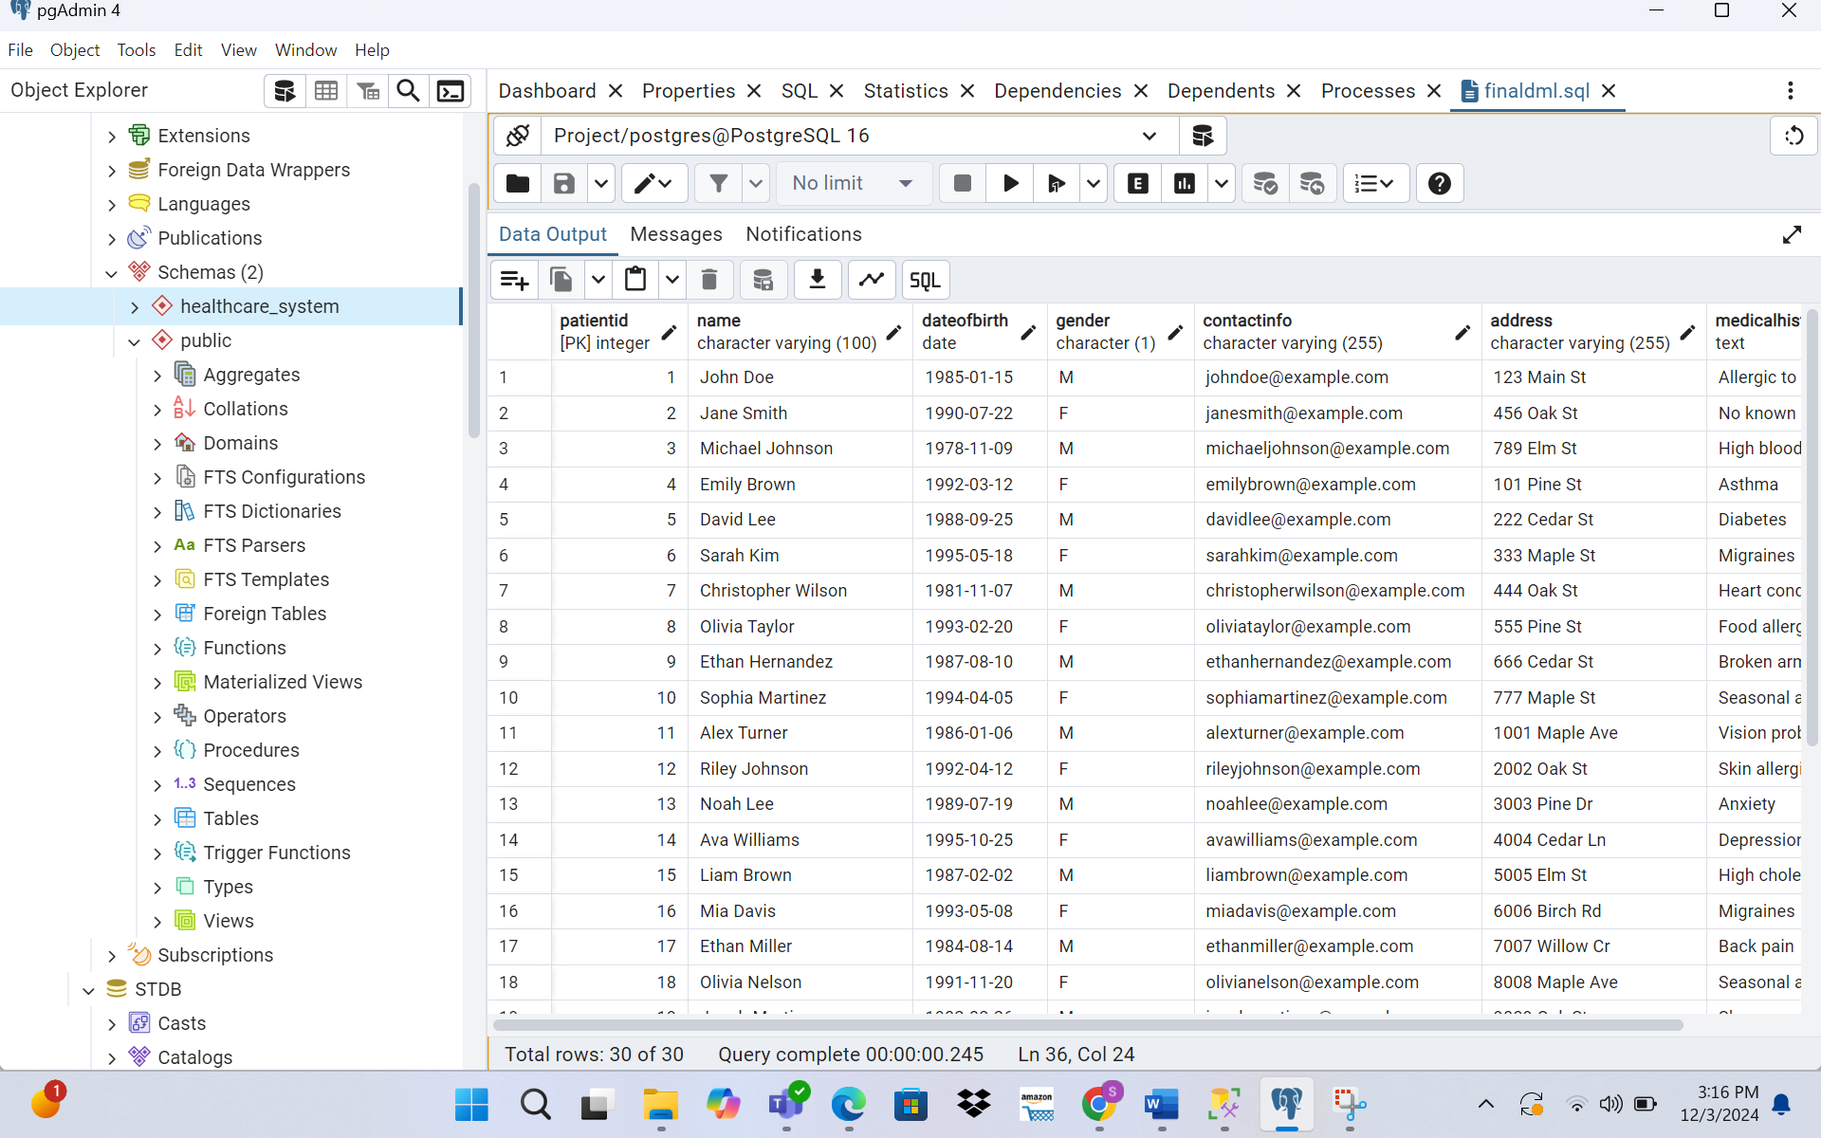

------Doctor table inserts

INSERT INTO Doctor (Name, Department, Specialty, Experience, ContactInfo)

VALUES

('Dr. John Smith', 'Cardiology', 'Cardiologist', 15, 'johnsmith@example.com'),

('Dr. Jane Doe', 'Pediatrics', 'Pediatrician', 10, 'janedoe@example.com'),

('Dr. Michael Johnson', 'Internal Medicine', 'Internal Medicine Specialist', 20, 'michaeljohnson@example.com'),

('Dr. Emily Brown', 'Dermatology', 'Dermatologist', 8, 'emilybrown@example.com'),

('Dr. David Lee', 'Orthopedics', 'Orthopedic Surgeon', 12, 'davidlee@example.com'),

('Dr. Sarah Kim', 'Neurology', 'Neurologist', 18, 'sarahkim@example.com'),

('Dr. Christopher Wilson', 'Gastroenterology', 'Gastroenterologist', 14, 'christopherwilson@example.com'),

('Dr. Olivia Taylor', 'Obstetrics and Gynecology', 'Obstetrician-Gynecologist', 16, 'oliviataylor@example.com'),

('Dr. Ethan Hernandez', 'Psychiatry', 'Psychiatrist', 12, 'ethanhernandez@example.com'),

('Dr. Sophia Martinez', 'Family Medicine', 'Family Physician', 10, 'sophiamartinez@example.com');

select * from doctor;

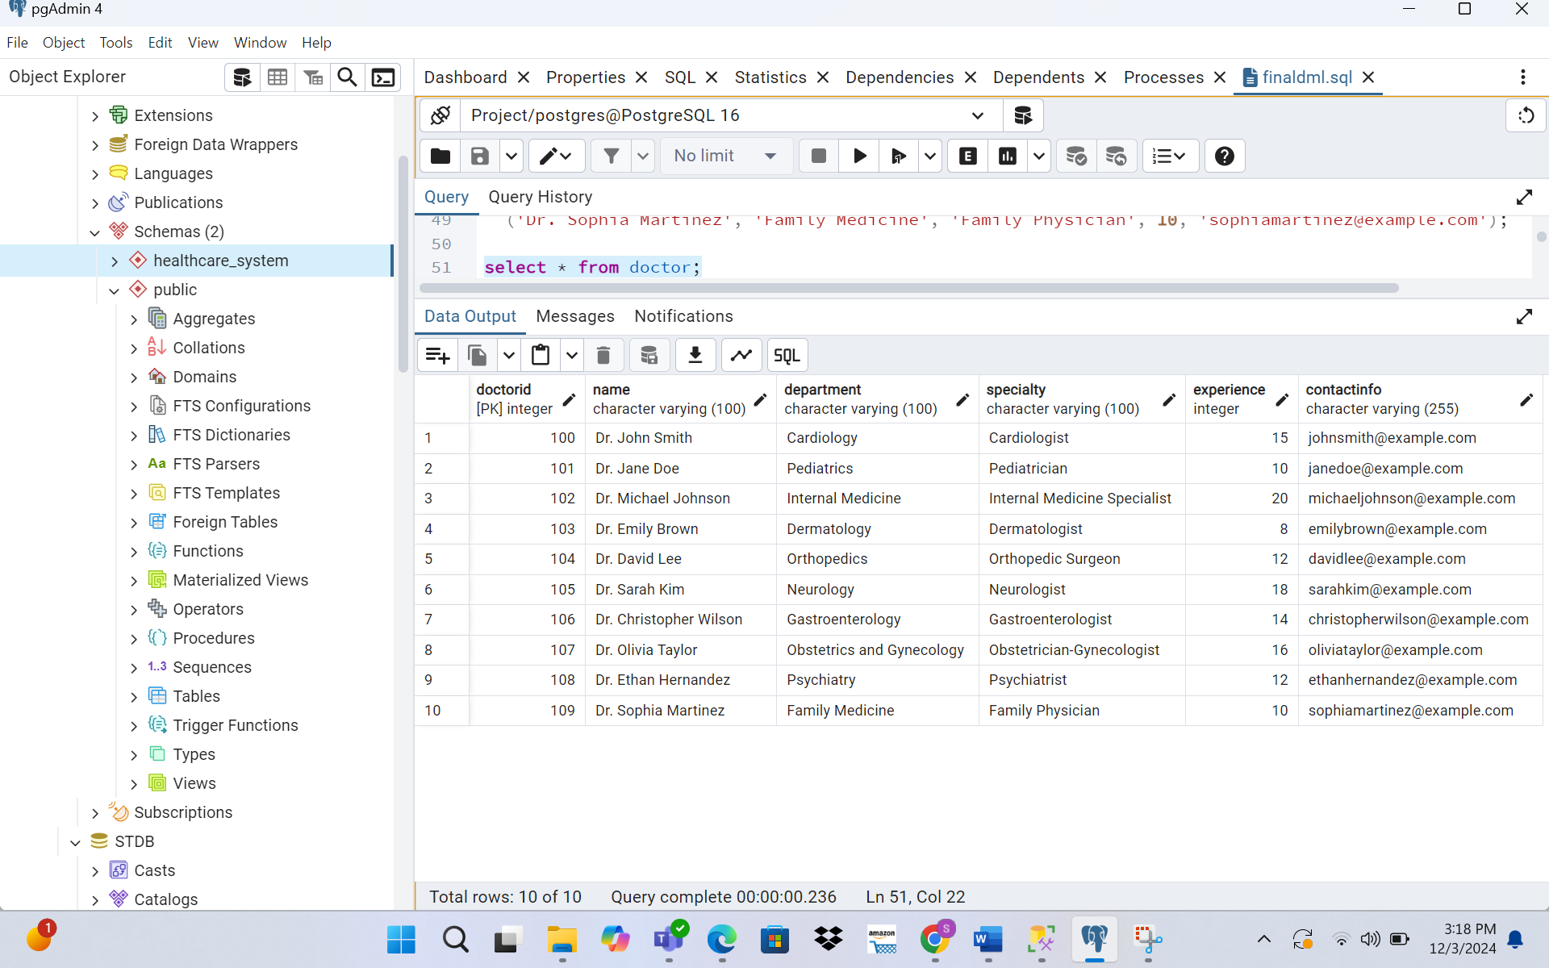

------- Appointment Table Inserts

INSERT INTO Appointment (PatientID, DoctorID, Date, AppointmentReason, Status)

VALUES

(1, 101, '2023-11-30', 'Annual Checkup', 'Scheduled'),

(2, 102, '2023-12-02', 'Follow-up Consultation', 'Scheduled'),

(3, 103, '2023-12-05', 'Urgent Care', 'Scheduled'),

(4, 101, '2023-12-07', 'Prescription Refill', 'Scheduled'),

(5, 102, '2023-12-10', 'Routine Checkup', 'Scheduled'),

(6, 103, '2023-12-12', 'Follow-up Consultation', 'Scheduled'),

(7, 101, '2023-12-15', 'Annual Checkup', 'Scheduled'),

(8, 102, '2023-12-17', 'Urgent Care', 'Scheduled'),

(9, 103, '2023-12-20', 'Routine Checkup', 'Scheduled'),

(10, 101, '2023-12-22', 'Prescription Refill', 'Scheduled');

select * from Appointment;

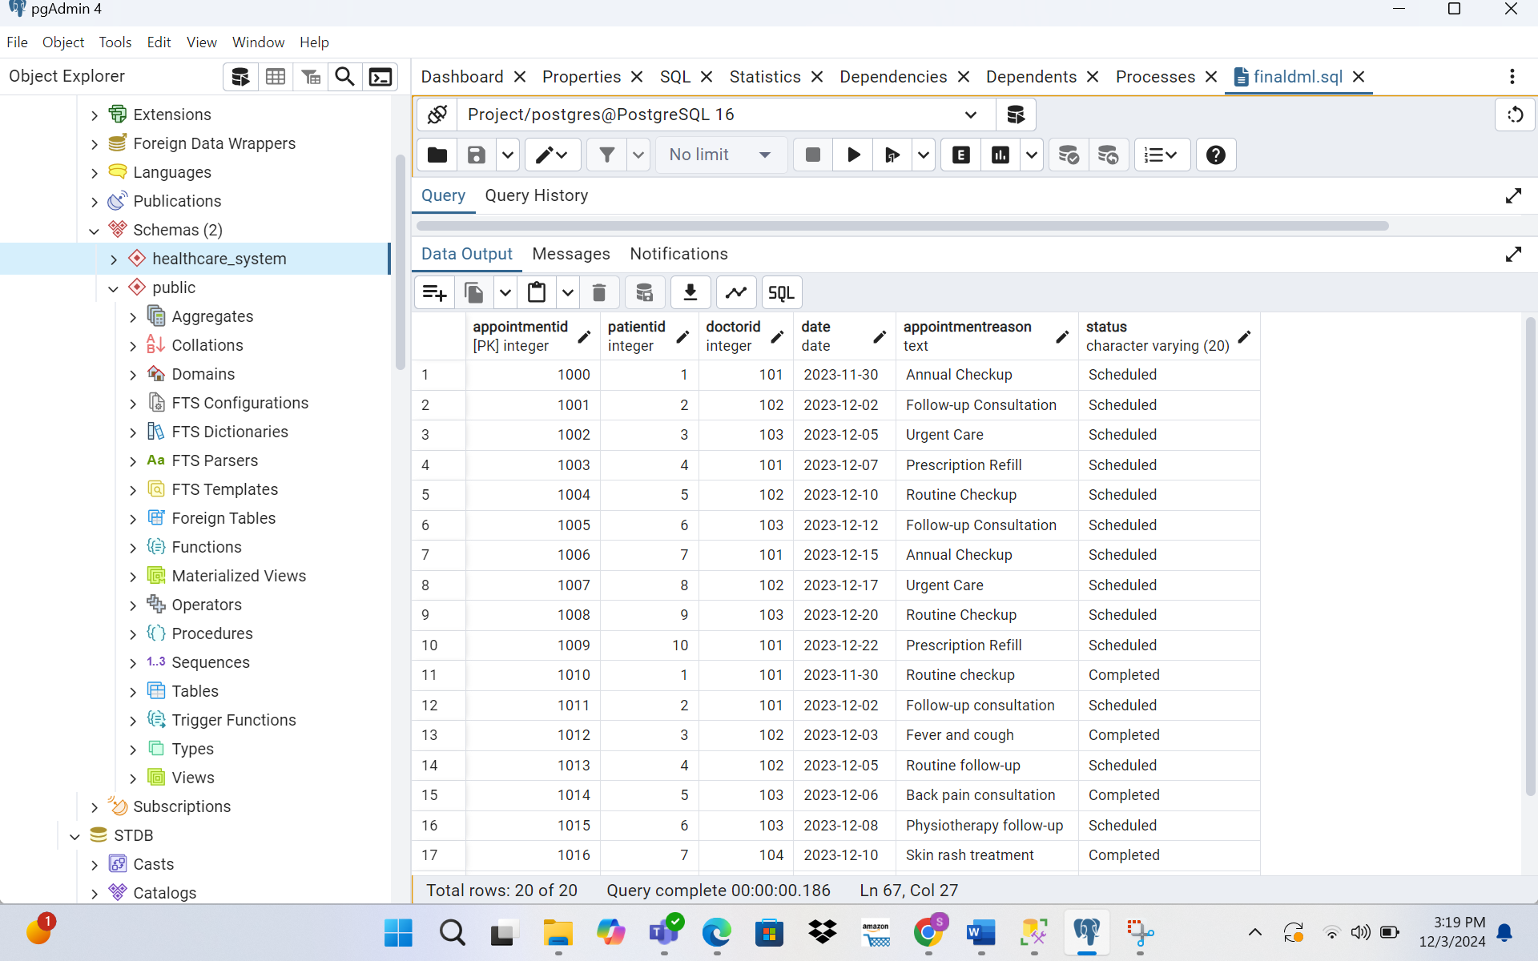

---------- MedicalRecord Inserts

INSERT INTO MedicalRecord (PatientID, AppointmentID, DoctorID, Notes, Treatment)

VALUES

(1, 1000, 101, 'Annual checkup performed. No issues.', 'Routine physical exam'),

(2, 1001, 102, 'Follow-up consultation for ongoing condition.', 'Medication adjusted'),

(3, 1002, 103, 'Presented with fever and cough.', 'Prescribed antibiotics'),

(4, 1003, 101, 'Requested refill for regular medication.', 'Medication refilled'),

(5, 1004, 102, 'Routine checkup completed.', 'Blood tests ordered'),

(6, 1005, 103, 'Patient reported back pain.', 'Prescribed physiotherapy'),

(7, 1006, 104, 'Skin rash diagnosed.', 'Prescribed ointment'),

(8, 1007, 105, 'Complained of frequent headaches.', 'MRI scan recommended'),

(9, 1008, 106, 'Routine dental checkup.', 'Teeth cleaned'),

(10, 1009, 107, 'Vision issues reported.', 'Prescribed glasses.');

select * from MedicalRecord;

-------Lab_Tests inserts

INSERT INTO Lab_Tests (RecordID, TestName, TestDate, Result, DoctorNotes)

VALUES

(3000, 'Blood Test', '2023-11-30', 'Normal', 'All parameters within range'),

(3001, 'X-Ray', '2023-12-02', 'Clear', 'No abnormalities detected'),

(3002, 'COVID-19 Test', '2023-12-05', 'Negative', 'No infection'),

(3003, 'Urine Test', '2023-12-07', 'Normal', 'Healthy kidney function'),

(3004, 'Lipid Profile', '2023-12-10', 'High cholesterol', 'Dietary changes recommended'),

(3005, 'MRI Scan', '2023-12-15', 'Normal', 'No abnormalities'),

(3006, 'CT Scan', '2023-12-20', 'Abnormal mass', 'Oncology referral needed'),

(3007, 'Allergy Test', '2023-12-25', 'Positive for dust allergy', 'Avoid exposure to dust'),

(3008, 'ECG', '2023-12-30', 'Irregular rhythm', 'Cardiology follow-up advised'),

(3009, 'Thyroid Function Test', '2024-01-05', 'Normal', 'No further action required');

select * from Lab_Tests;

---------- Billing Table Inserts

INSERT INTO Billing (PatientID, AppointmentID, TotalAmount, Date, PaymentStatus, InsuranceDetails)

VALUES

(1, 1000, 150.00, '2023-11-30', 'Paid', 'Blue Cross Insurance'),

(2, 1001, 200.00, '2023-12-02', 'Pending', 'UnitedHealth Insurance'),

(3, 1002, 300.00, '2023-12-05', 'Paid', 'Aetna Insurance'),

(4, 1003, 50.00, '2023-12-07', 'Pending', 'Blue Cross Insurance'),

(5, 1004, 100.00, '2023-12-10', 'Paid', 'UnitedHealth Insurance'),

(6, 1005, 250.00, '2023-12-12', 'Paid', 'Medicare'),

(7, 1006, 175.00, '2023-12-15', 'Pending', 'Cigna Insurance'),

(8, 1007, 400.00, '2023-12-17', 'Paid', 'Kaiser Permanente'),

(9, 1008, 300.00, '2023-12-20', 'Pending', 'Humana'),

(10, 1009, 120.00, '2023-12-22', 'Paid', 'Aetna Insurance');

SELECT * FROM Billing;

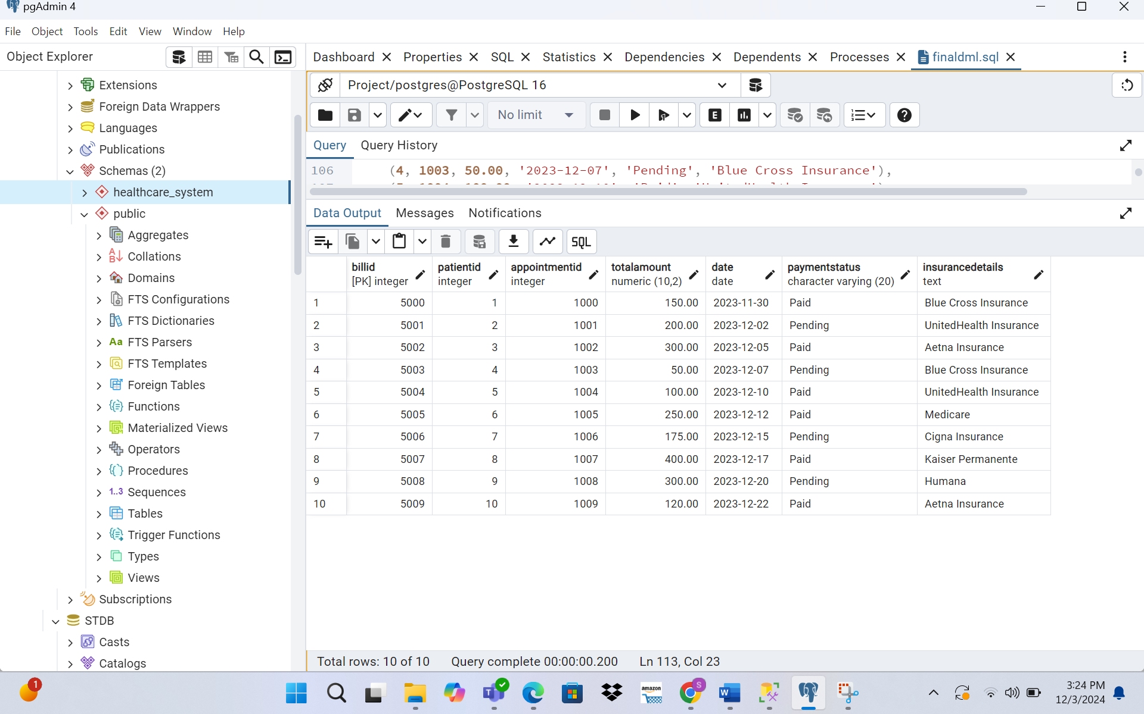

-------Lab_Test Table Inserts

INSERT INTO Lab_Tests (RecordID, TestName, TestDate, Result, DoctorNotes)

VALUES

-- Lab tests for MedicalRecord with RecordID = 3000

(3000, 'Blood Test', '2023-11-30', 'Normal', 'No abnormalities detected'),

(3000, 'Lipid Profile', '2023-12-01', 'High cholesterol', 'Dietary changes recommended'),

-- Lab tests for MedicalRecord with RecordID = 3001

(3001, 'X-Ray', '2023-12-02', 'Clear', 'No abnormalities detected'),

(3001, 'ECG', '2023-12-03', 'Irregular rhythm', 'Follow-up with cardiologist recommended'),

-- Lab tests for MedicalRecord with RecordID = 3002

(3002, 'COVID-19 Test', '2023-12-05', 'Negative', 'No infection detected'),

(3002, 'Blood Sugar Test', '2023-12-05', 'Elevated', 'Possible pre-diabetic condition'),

-- Lab tests for MedicalRecord with RecordID = 3003

(3003, 'Urine Test', '2023-12-07', 'Normal', 'No abnormalities'),

(3003, 'Allergy Test', '2023-12-08', 'Positive for pollen allergy', 'Avoid pollen exposure'),

-- Lab tests for MedicalRecord with RecordID = 3004

(3004, 'MRI Scan', '2023-12-10', 'Normal', 'No issues detected'),

(3004, 'Thyroid Function Test', '2023-12-11', 'Normal', 'No further action required');

select * from lab_tests;

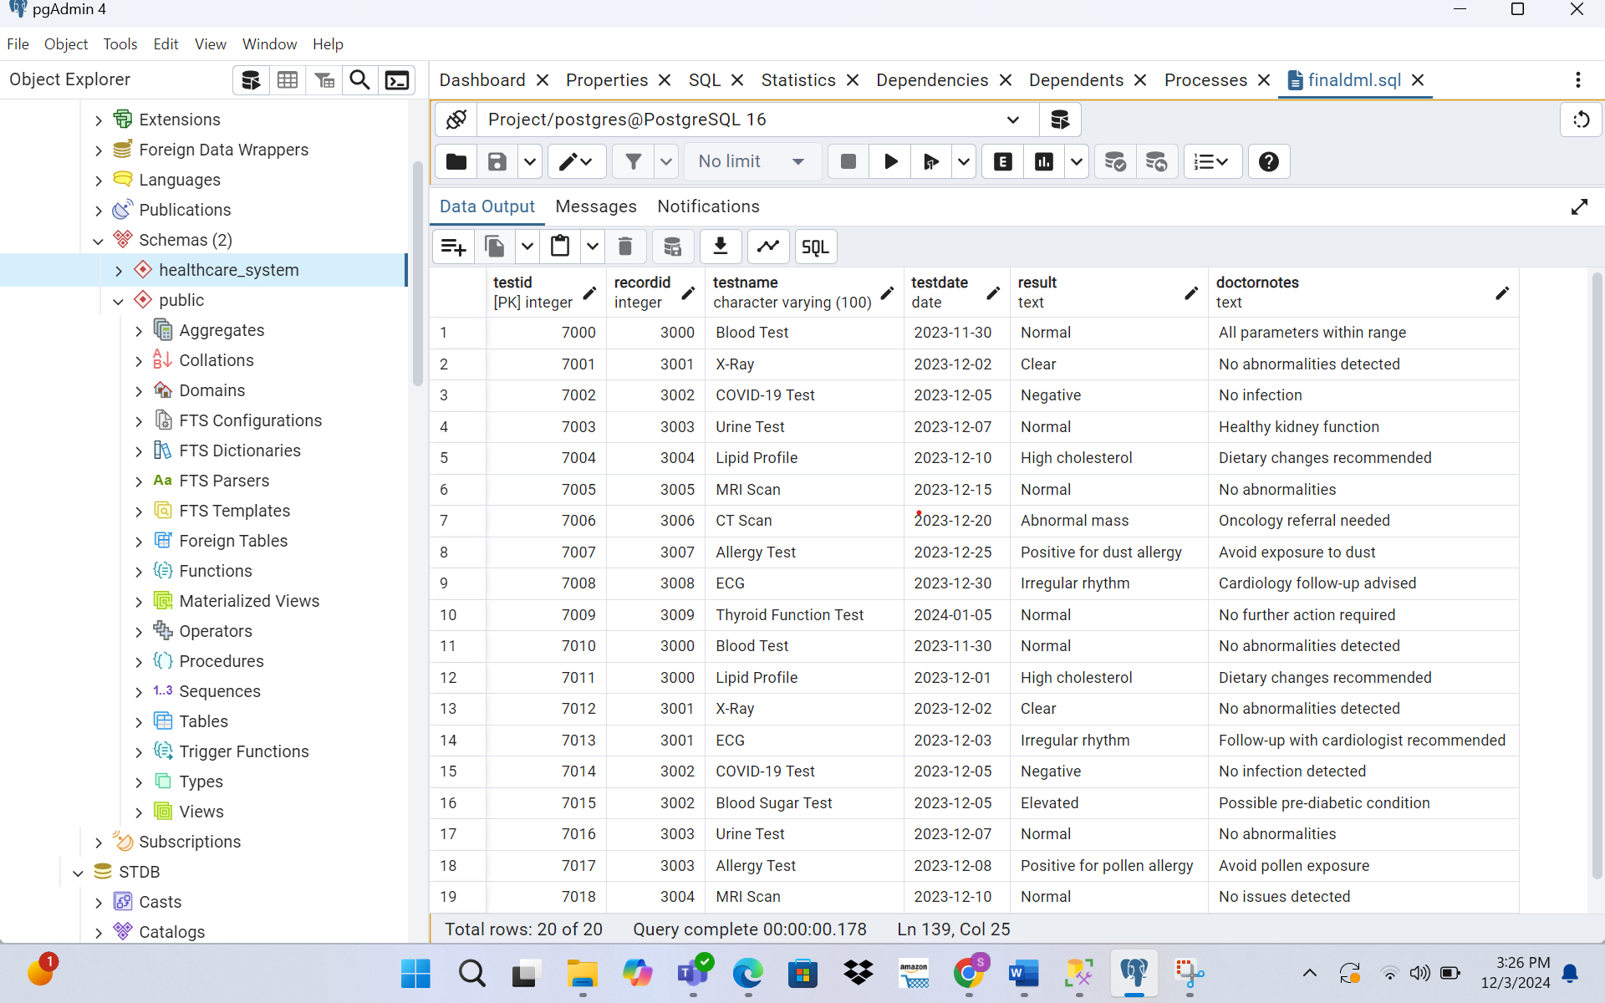

--------MedicalRecord Table Inserts

INSERT INTO MedicalRecord (PatientID, AppointmentID, DoctorID, Notes, Treatment)

VALUES

-- Records associated with DoctorID = 101

(1, 1000, 101, 'Annual checkup. Patient is in good health.', 'Routine physical exam'),

(2, 1001, 101, 'Follow-up consultation. Blood pressure stabilized.', 'Prescription for blood pressure control'),

-- Records associated with DoctorID = 102

(3, 1002, 102, 'Patient presented with fever and cough.', 'Prescribed antibiotics for infection'),

(4, 1003, 102, 'Routine follow-up. Symptoms improving.', 'Continued medication for infection'),

-- Records associated with DoctorID = 103

(5, 1004, 103, 'Patient reported back pain after injury.', 'Recommended physiotherapy sessions'),

(6, 1005, 103, 'Check-up after physiotherapy. Pain reduced.', 'Advised continuation of exercises'),

-- Records associated with DoctorID = 104

(7, 1006, 104, 'Patient presented with skin rash.', 'Prescribed antihistamine ointment'),

(8, 1007, 104, 'Follow-up for skin rash. Symptoms resolved.', 'No further treatment required'),

-- Records associated with DoctorID = 105

(9, 1008, 105, 'Patient reported persistent headaches.', 'Ordered MRI scan for further evaluation'),

(10, 1009, 105, 'MRI results normal. Advised stress management.', 'No medical intervention required');

select * from MedicalRecord;

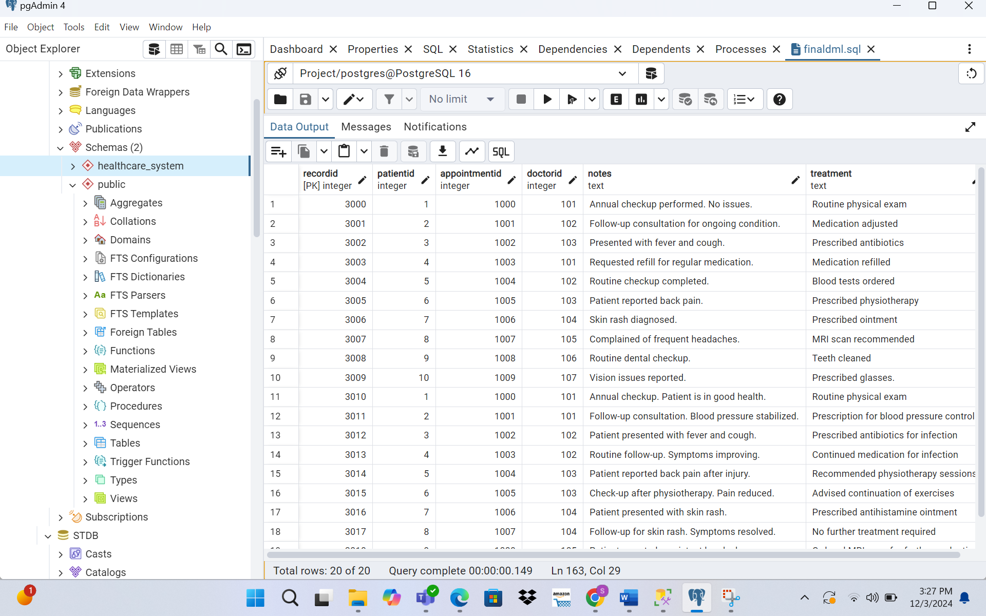

------Appointment Table Inserts

INSERT INTO Appointment (PatientID, DoctorID, Date, AppointmentReason, Status)

VALUES

-- Appointments for DoctorID = 101

(1, 101, '2023-11-30', 'Routine checkup', 'Completed'),

(2, 101, '2023-12-02', 'Follow-up consultation', 'Scheduled'),

-- Appointments for DoctorID = 102

(3, 102, '2023-12-03', 'Fever and cough', 'Completed'),

(4, 102, '2023-12-05', 'Routine follow-up', 'Scheduled'),

-- Appointments for DoctorID = 103

(5, 103, '2023-12-06', 'Back pain consultation', 'Completed'),

(6, 103, '2023-12-08', 'Physiotherapy follow-up', 'Scheduled'),

-- Appointments for DoctorID = 104

(7, 104, '2023-12-10', 'Skin rash treatment', 'Completed'),

(8, 104, '2023-12-12', 'Dermatology follow-up', 'Scheduled'),

-- Appointments for DoctorID = 105

(9, 105, '2023-12-14', 'Headache diagnosis', 'Completed'),

(10, 105, '2023-12-16', 'MRI scan review', 'Scheduled');

select * from Appointment;

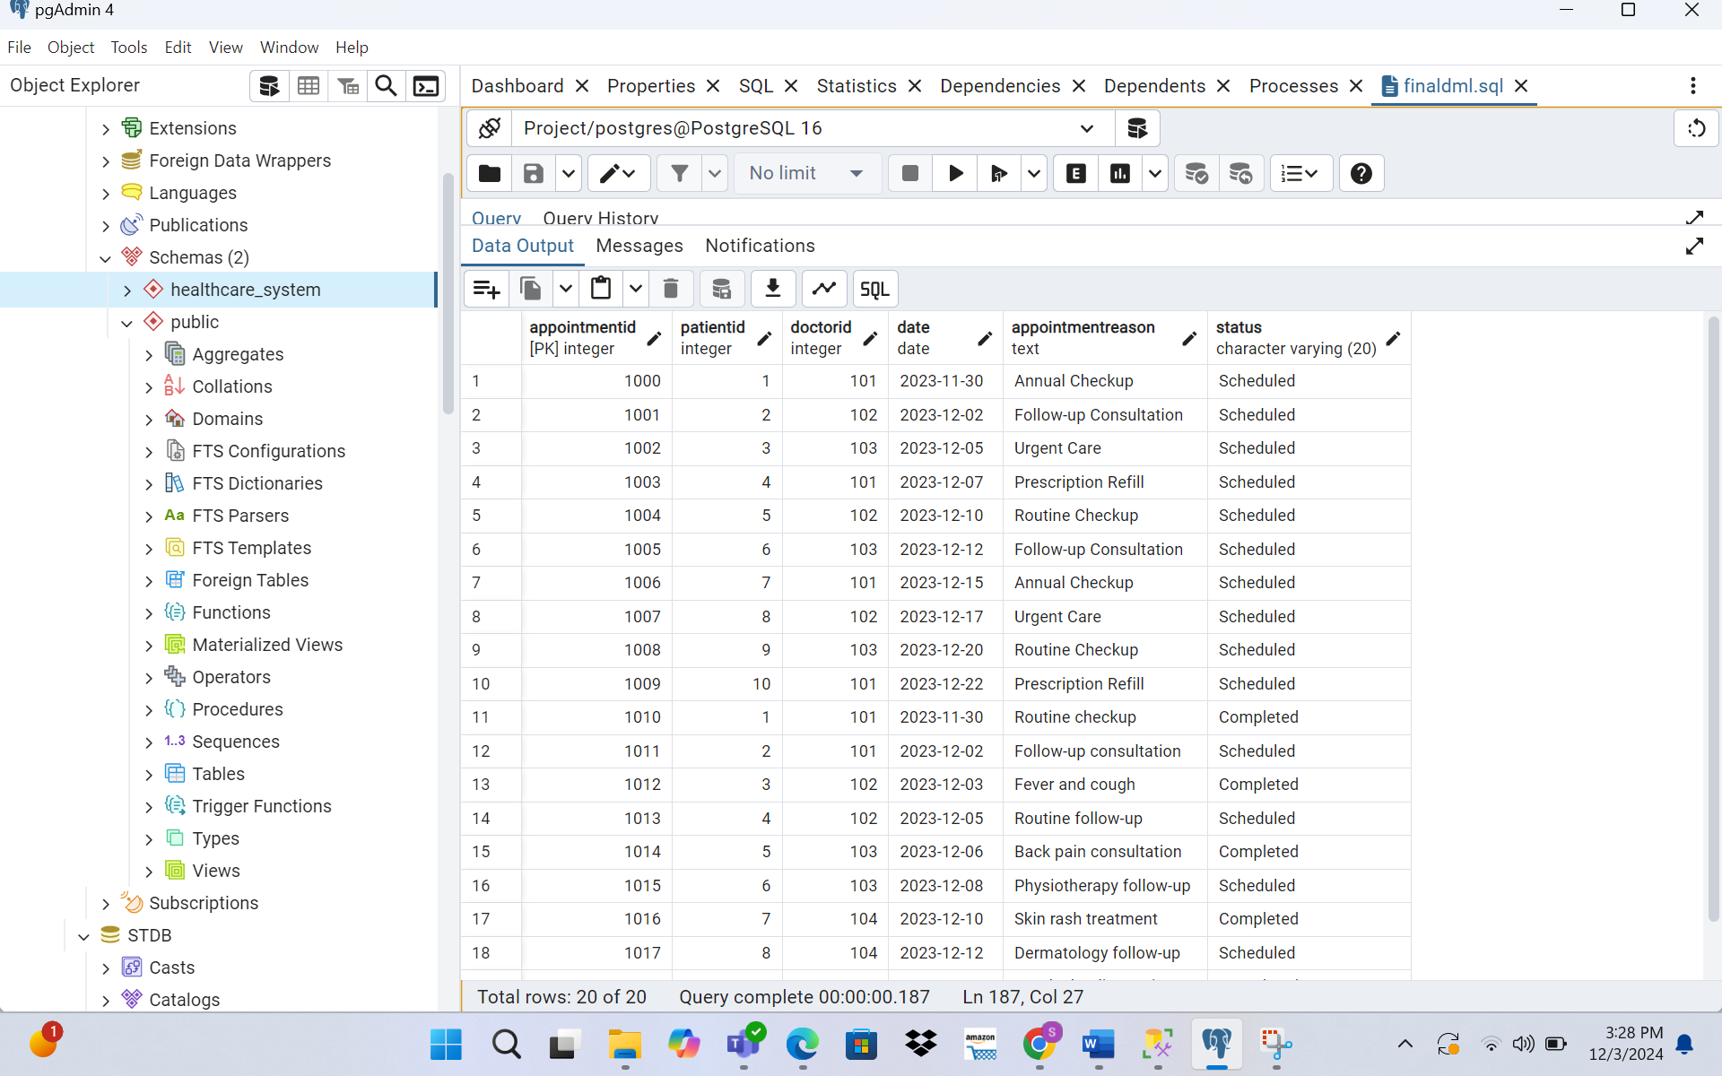

b) Query code and Output:

**➢ Query 1: Select all columns and all rows from one table.**

SELECT *

FROM Patients;

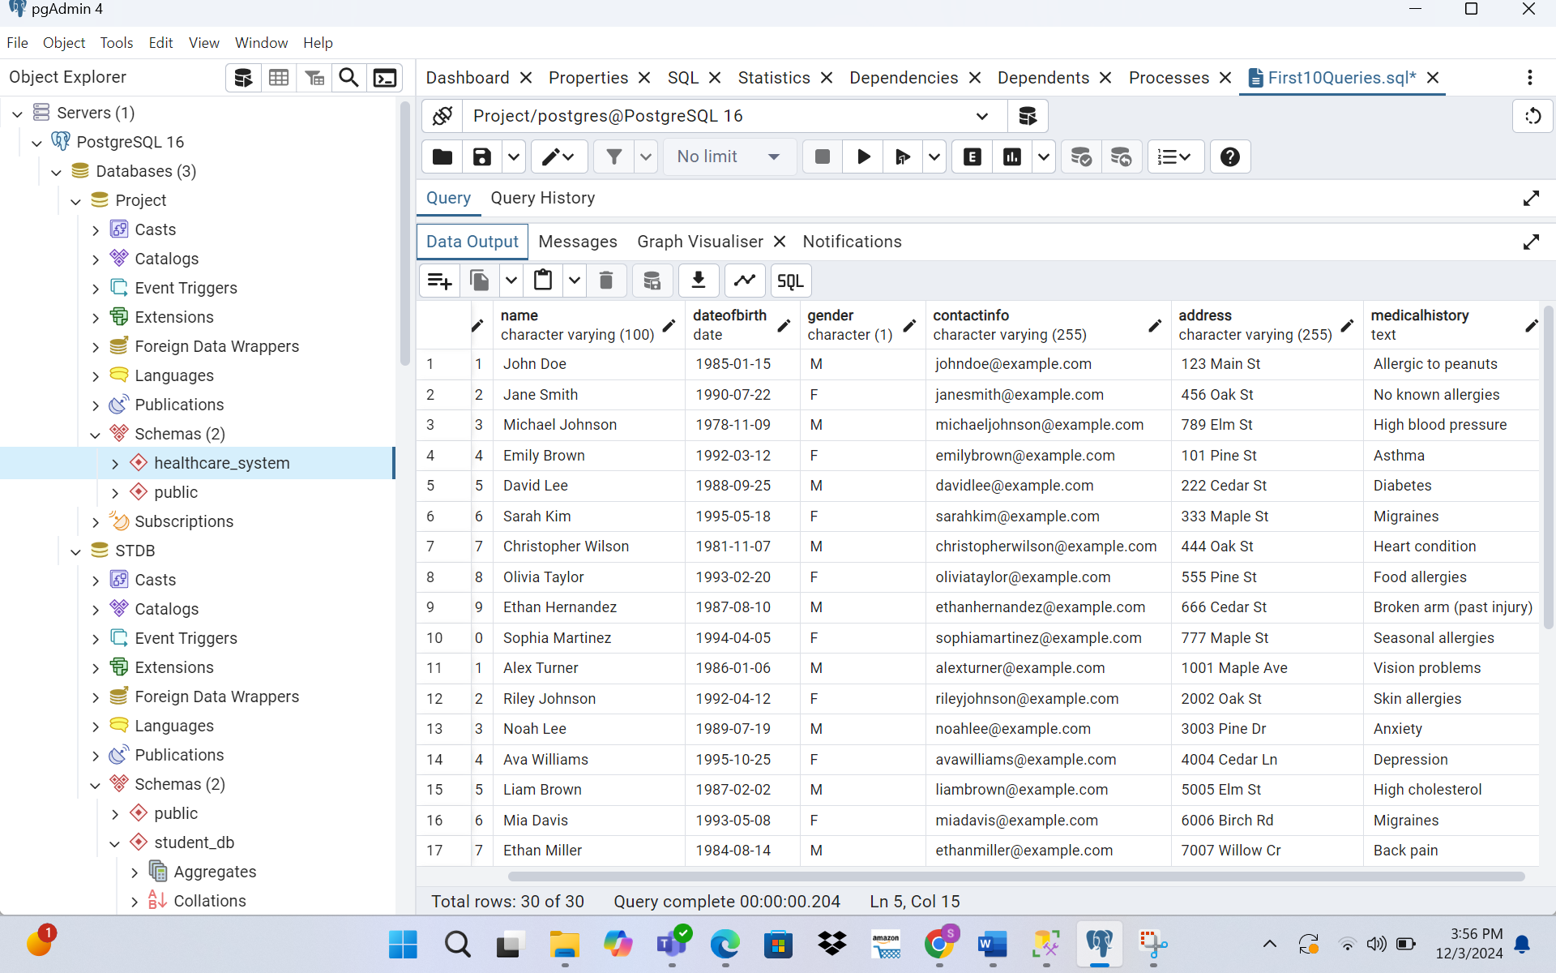

**➢ Query 2: Select five columns and all rows from one table.**

SELECT Name, DateOfBirth, Gender, ContactInfo, Address

FROM Patients;

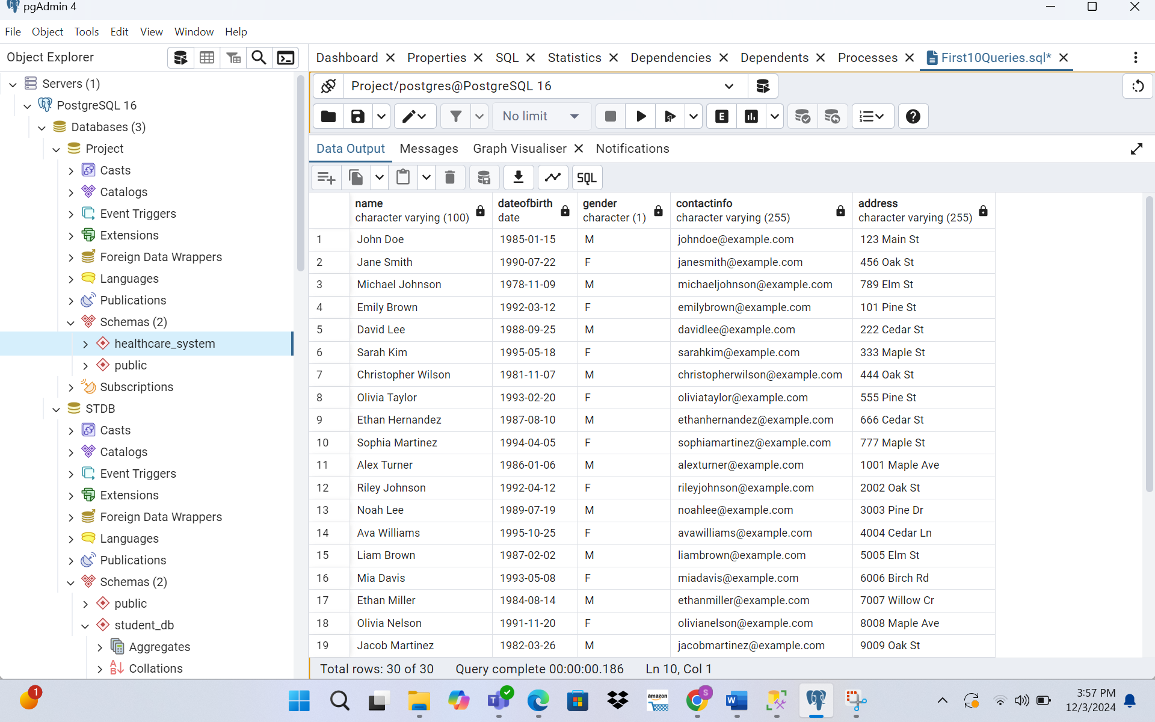

**➢ Query 3: Select all columns from all rows from one view.**

-----creating a view:

CREATE OR REPLACE VIEW PatientAppointmentsView AS

SELECT

p.PatientID,

p.Name AS PatientName,

p.DateOfBirth,

a.AppointmentID,

a.Date AS AppointmentDate,

a.AppointmentReason,

a.Status

FROM

Patients p

JOIN

Appointment a ON p.PatientID = a.PatientID;

------------displaying it

SELECT *

FROM PatientAppointmentsView;

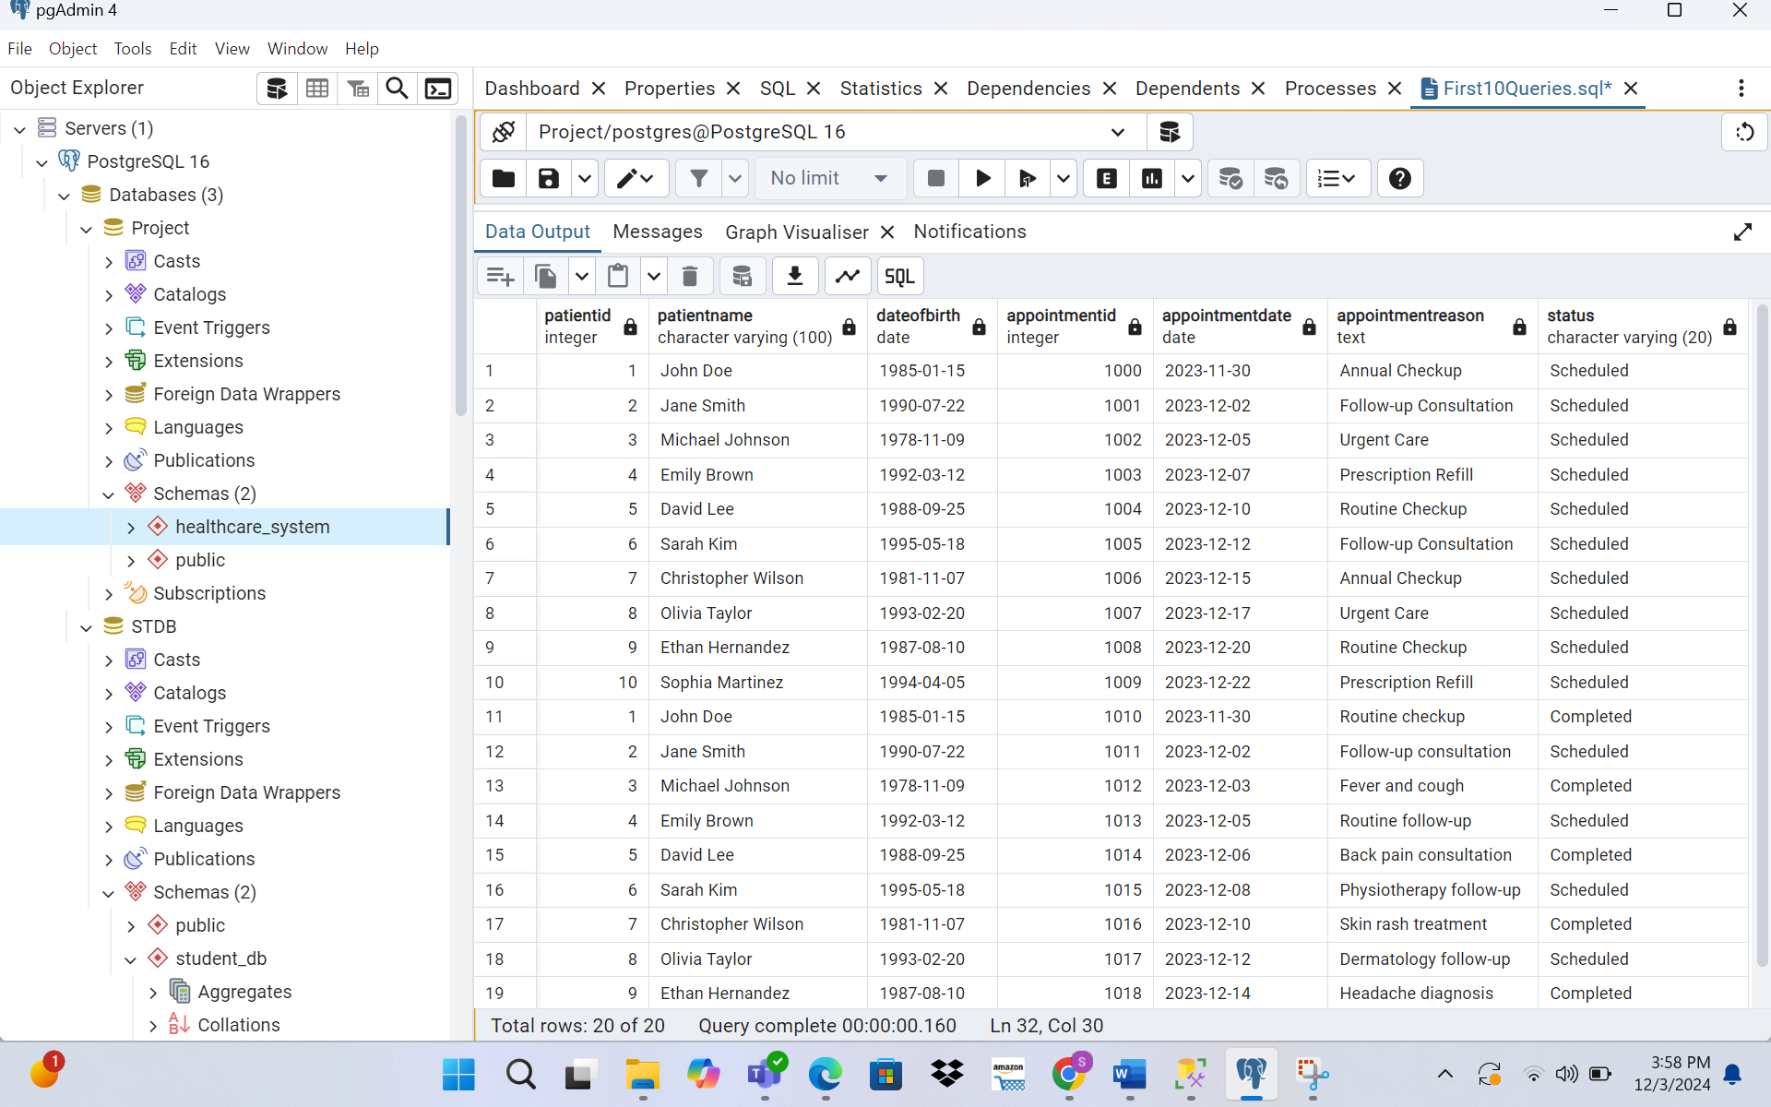

**➢ Query 4: Using a join on 2 tables, select all columns and all rows from the tables without the use of a Cartesian product.**

SELECT *

FROM Appointment a

JOIN Patients p ON a.PatientID = p.PatientID;

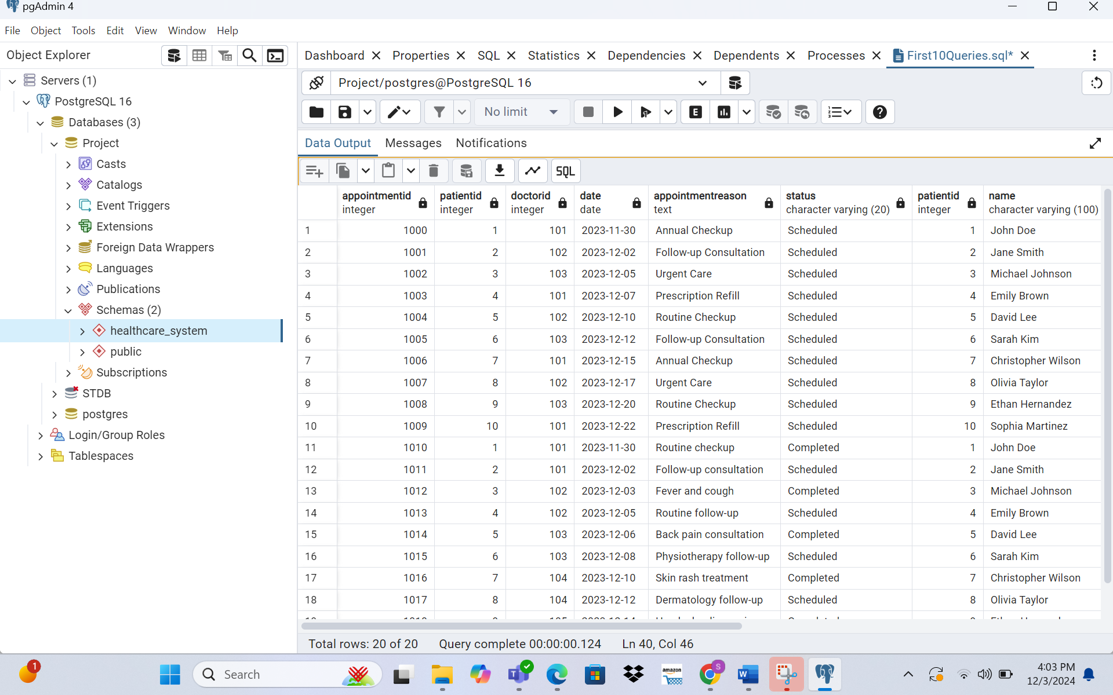

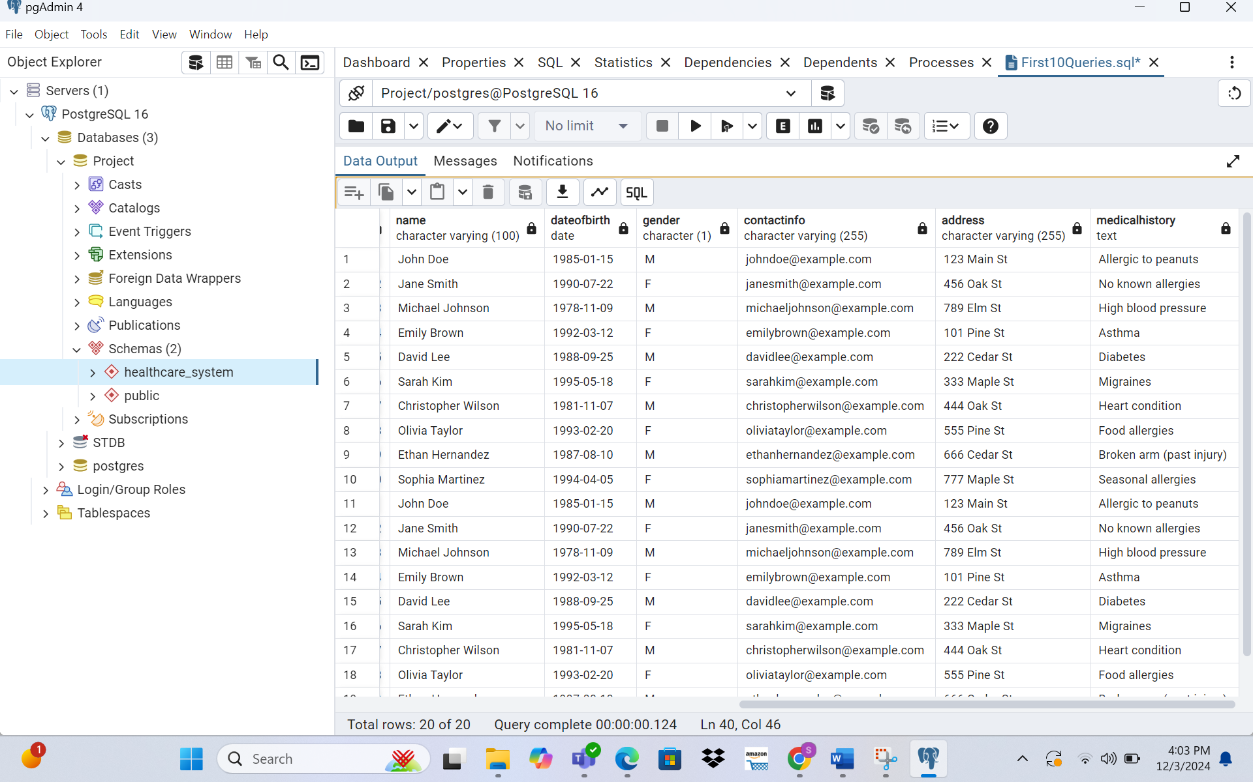

**➢ Query 5: Select and order data retrieved from one table.**

SELECT Name, DateOfBirth

FROM Patients

ORDER BY DateOfBirth ASC;

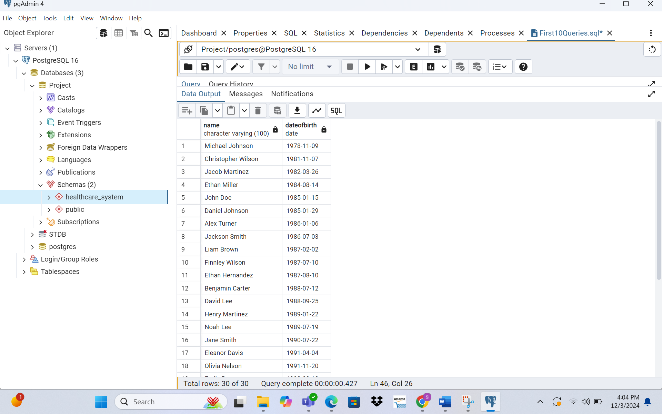

**➢ Query 6: Using a join on 3 tables, select 5 columns from the 3 tables. Use syntax that would limit the output to 3 rows.**

SELECT p.Name AS PatientName, d.Name AS DoctorName, a.Date AS AppointmentDate, a.AppointmentReason, a.Status

FROM Patients p

JOIN Appointment a ON p.PatientID = a.PatientID

JOIN Doctor d ON a.DoctorID = d.DoctorID

LIMIT 3;

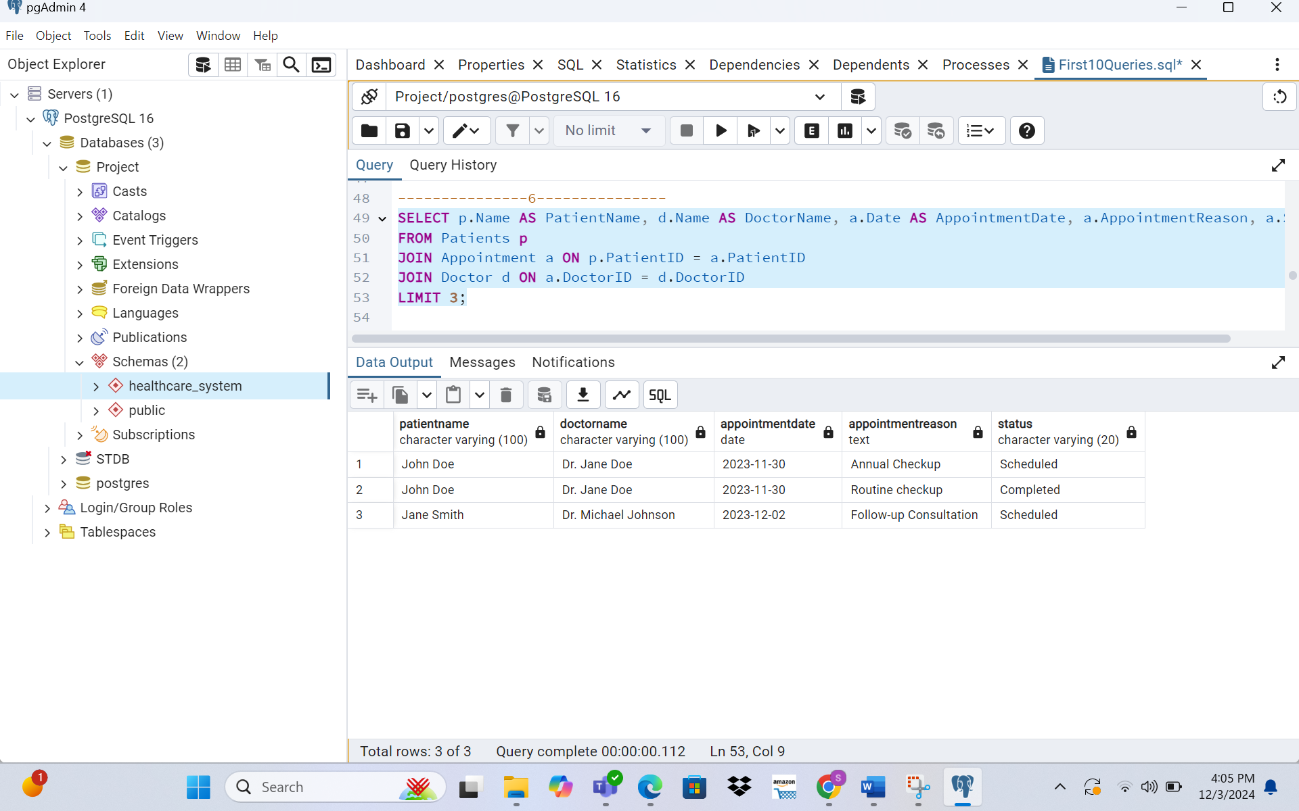

**➢ Query 7: Select distinct rows using joins on 3 tables.**

SELECT DISTINCT p.Name AS PatientName, d.Name AS DoctorName, a.AppointmentReason

FROM Patients p

JOIN Appointment a ON p.PatientID = a.PatientID

JOIN Doctor d ON a.DoctorID = d.DoctorID;

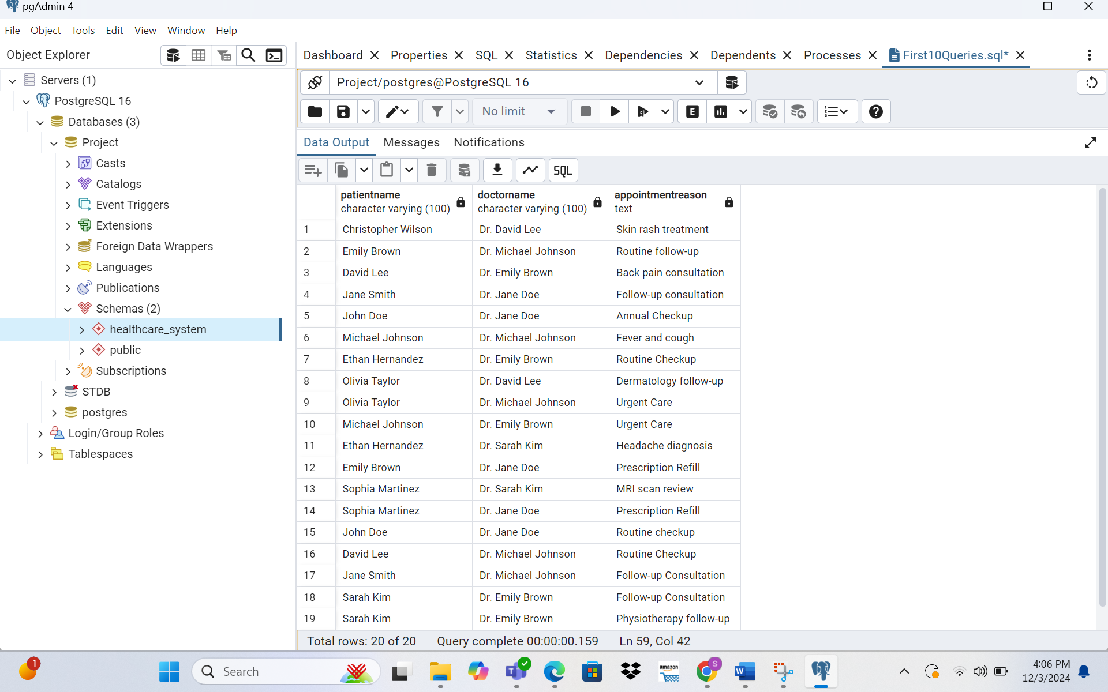

**➢ Query 8: Use GROUP BY and HAVING in a select statement using one or more tables.**

SELECT a.DoctorID, COUNT(a.AppointmentID) AS TotalAppointments

FROM Appointment a

GROUP BY a.DoctorID

HAVING COUNT(a.AppointmentID) > 2;

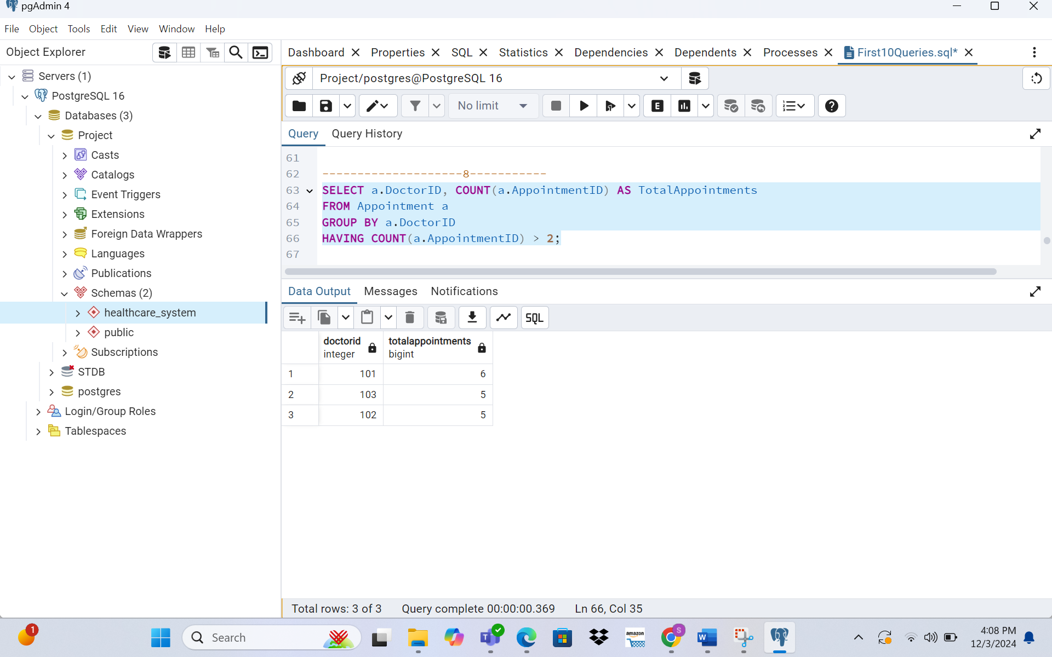

**➢ Query 9: Use IN clause to select data from one or more tables**

SELECT Name, DateOfBirth

FROM Patients

WHERE PatientID IN (SELECT PatientID FROM Appointment WHERE Status = 'Completed');

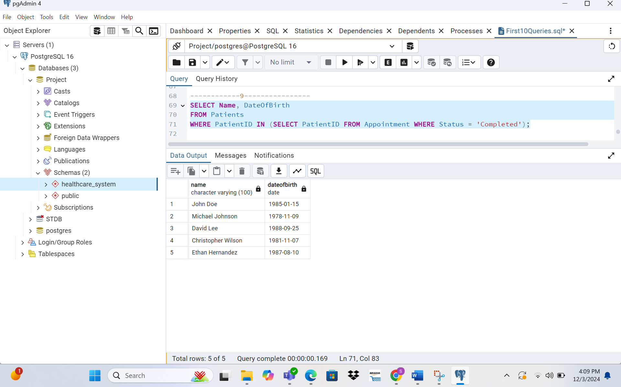

**➢ Query 10: Select length of one column from one table (use LENGTH function).**

SELECT Name, LENGTH(Name) AS NameLength

FROM Patients;

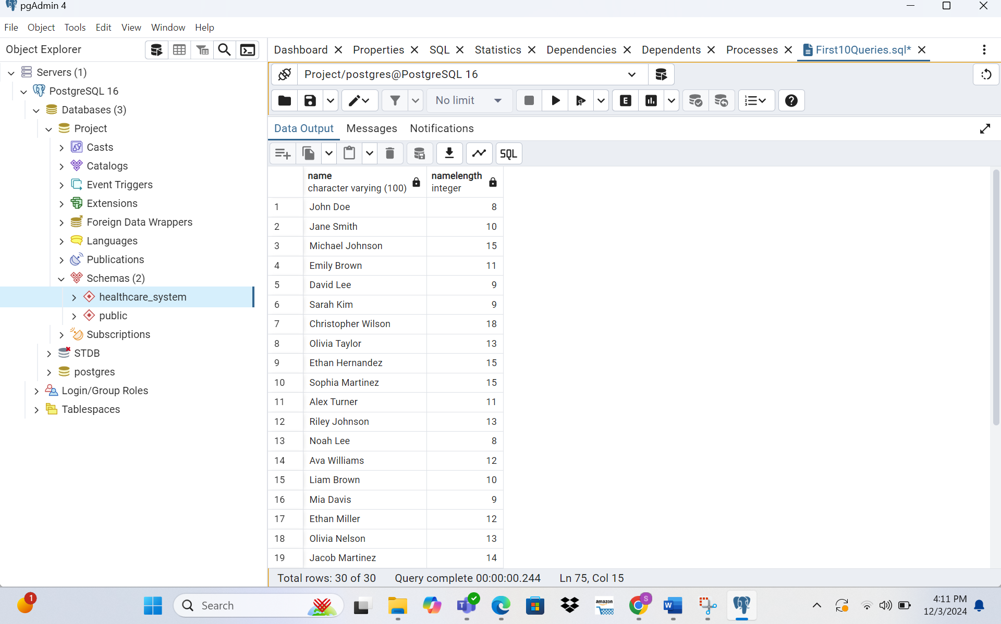

**➢ Query 11: Delete one record from one table. Use select statements to demonstrate the table contents before and after the DELETE statement. Make sure you use ROLLBACK afterwards so that the data will not be physically removed.**

SELECT * FROM patients;

BEGIN;

DELETE FROM patients

WHERE patientid = 23;

SELECT * FROM patients;

ROLLBACK;

SELECT * FROM patients;

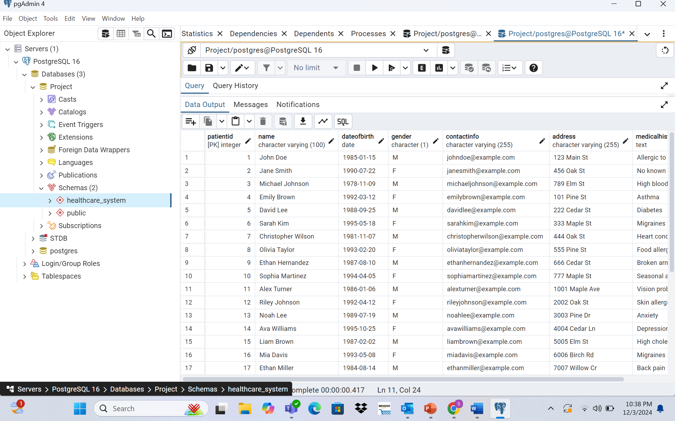

**➢ Query 12: Update one record from one table. Use select statements to demonstrate the table contents before and after the UPDATE statement. Make sure you use ROLLBACK afterwards so**

Select records before update

SELECT *

FROM Patients;

BEGIN;

-- Update a record

UPDATE Patients

SET ContactInfo = 'updated_email2@example.com'

WHERE PatientID = 4;

-- Select records after update

SELECT *

FROM Patients;

-- Rollback to undo the update

ROLLBACK;

SELECT * FROM patients;

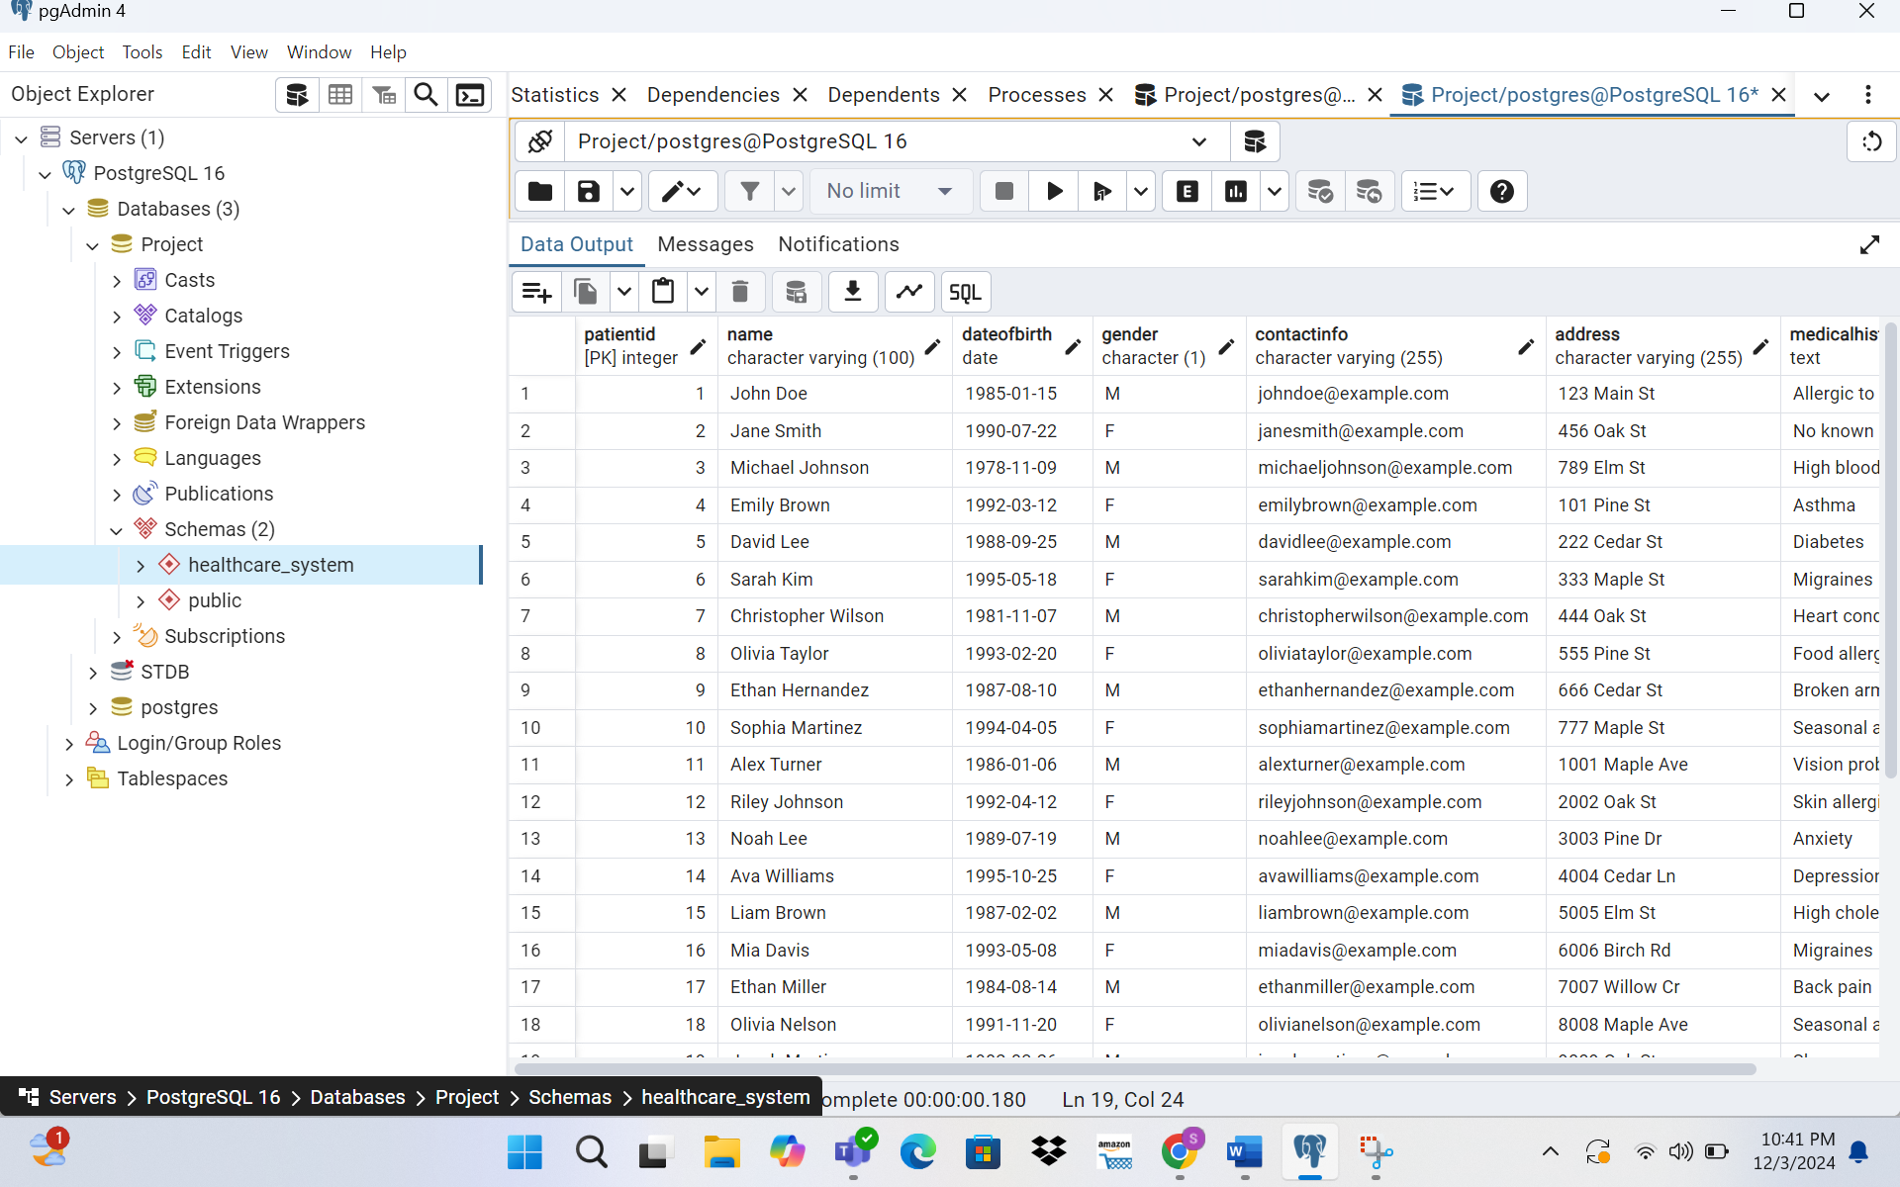

**➢ Query 13: Show Total Sales and Average Order Value per Restaurant.**

SELECT d.Name AS DoctorName,

COUNT(a.AppointmentID) AS TotalAppointments,

SUM(b.TotalAmount) AS TotalRevenue

FROM Doctor d

JOIN Appointment a ON d.DoctorID = a.DoctorID

JOIN Billing b ON a.AppointmentID = b.AppointmentID

GROUP BY d.Name

ORDER BY TotalRevenue DESC;

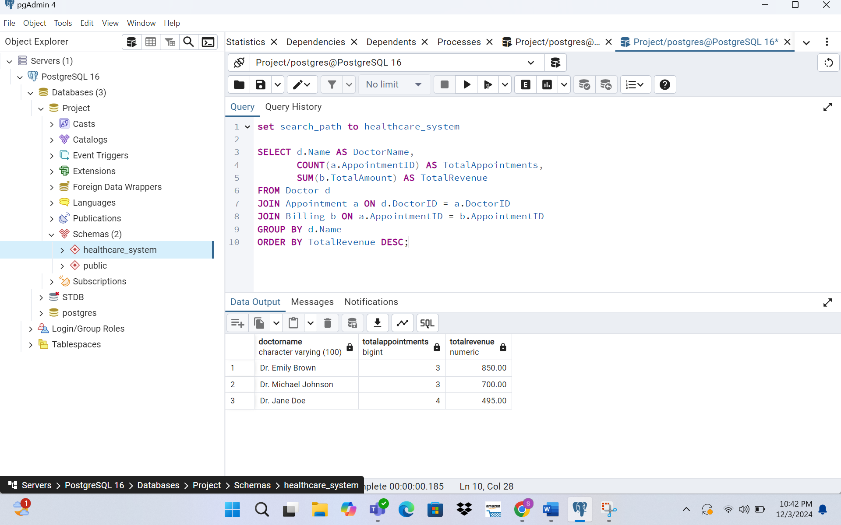

**➢ Query 14: Who are the top 3 customers who placed the most orders, and what is the restaurant they ordered from the most, along with the number of orders at their favorite restaurant?**

SELECT DISTINCT p.Name AS PatientName

FROM Patients p

JOIN MedicalRecord m ON p.PatientID = m.PatientID

JOIN Lab_Tests l ON m.RecordID = l.RecordID

WHERE p.PatientID NOT IN (

SELECT b.PatientID

FROM Billing b

WHERE b.PaymentStatus = 'Pending'

);

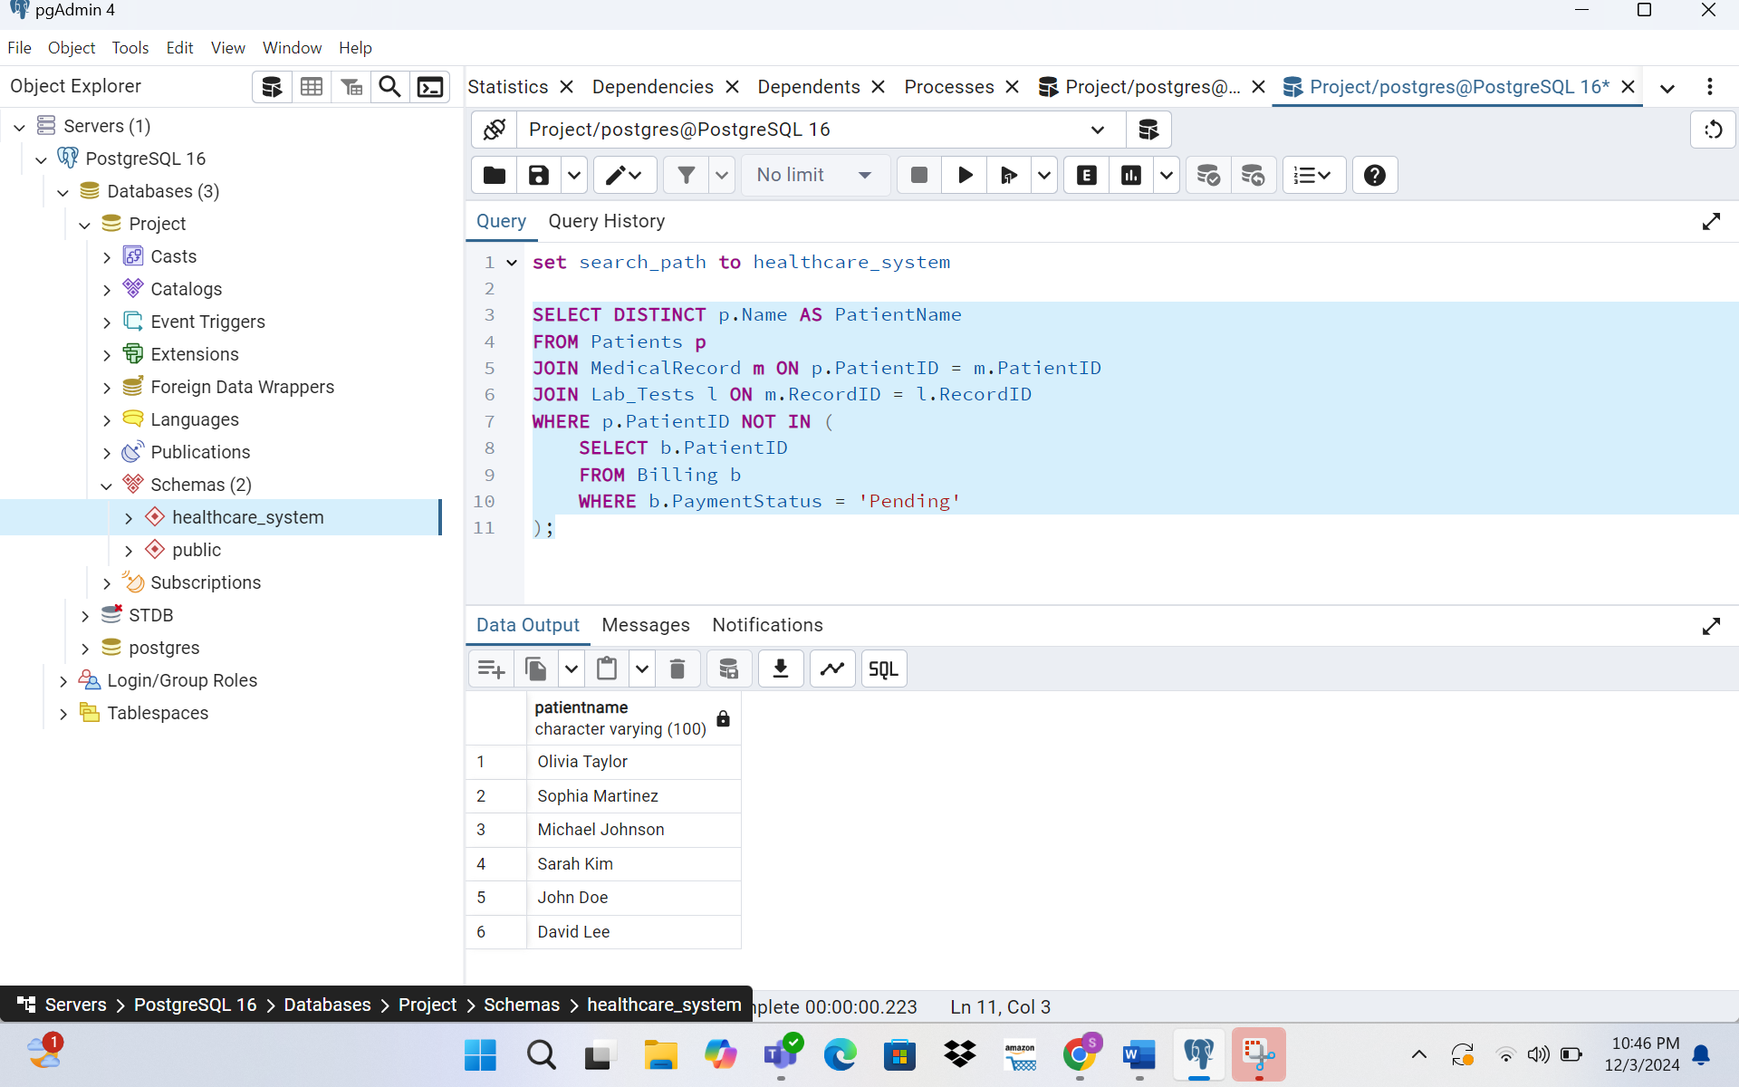

4. Conclusion:

In conclusion, the database design of the Health Care Management System is crucial for smooth and efficient operations. It helps manage patient records, appointments, and billing effectively while ensuring data security. A good database design supports better healthcare delivery and provides a strong foundation for future improvements.